**SimAgile Execution 1 Report - Team Based Response (40 Points)**

***Please use the following link to access SimAgile:*** [***http://agile.simproject.com/***](http://agile.simproject.com/)***. Complete an execution from beginning to end and answer the questions that follow. If the above link doesn’t work, try opening the link in private browsing mode.***

***Important Note: if you receive an error while using SimAgile, please try rebooting your computer. If the problem isn’t fixed, please send an email to*** [***support@simulationpl.com***](mailto:support@simulationpl.com)***.***

**Sprint 1 - Week 1 and Week 2 (10 Points)**

**Product Backlog (one screen shot for sprint 1)**

* Paste a screen shot of your product backlog prior to starting sprint 1.

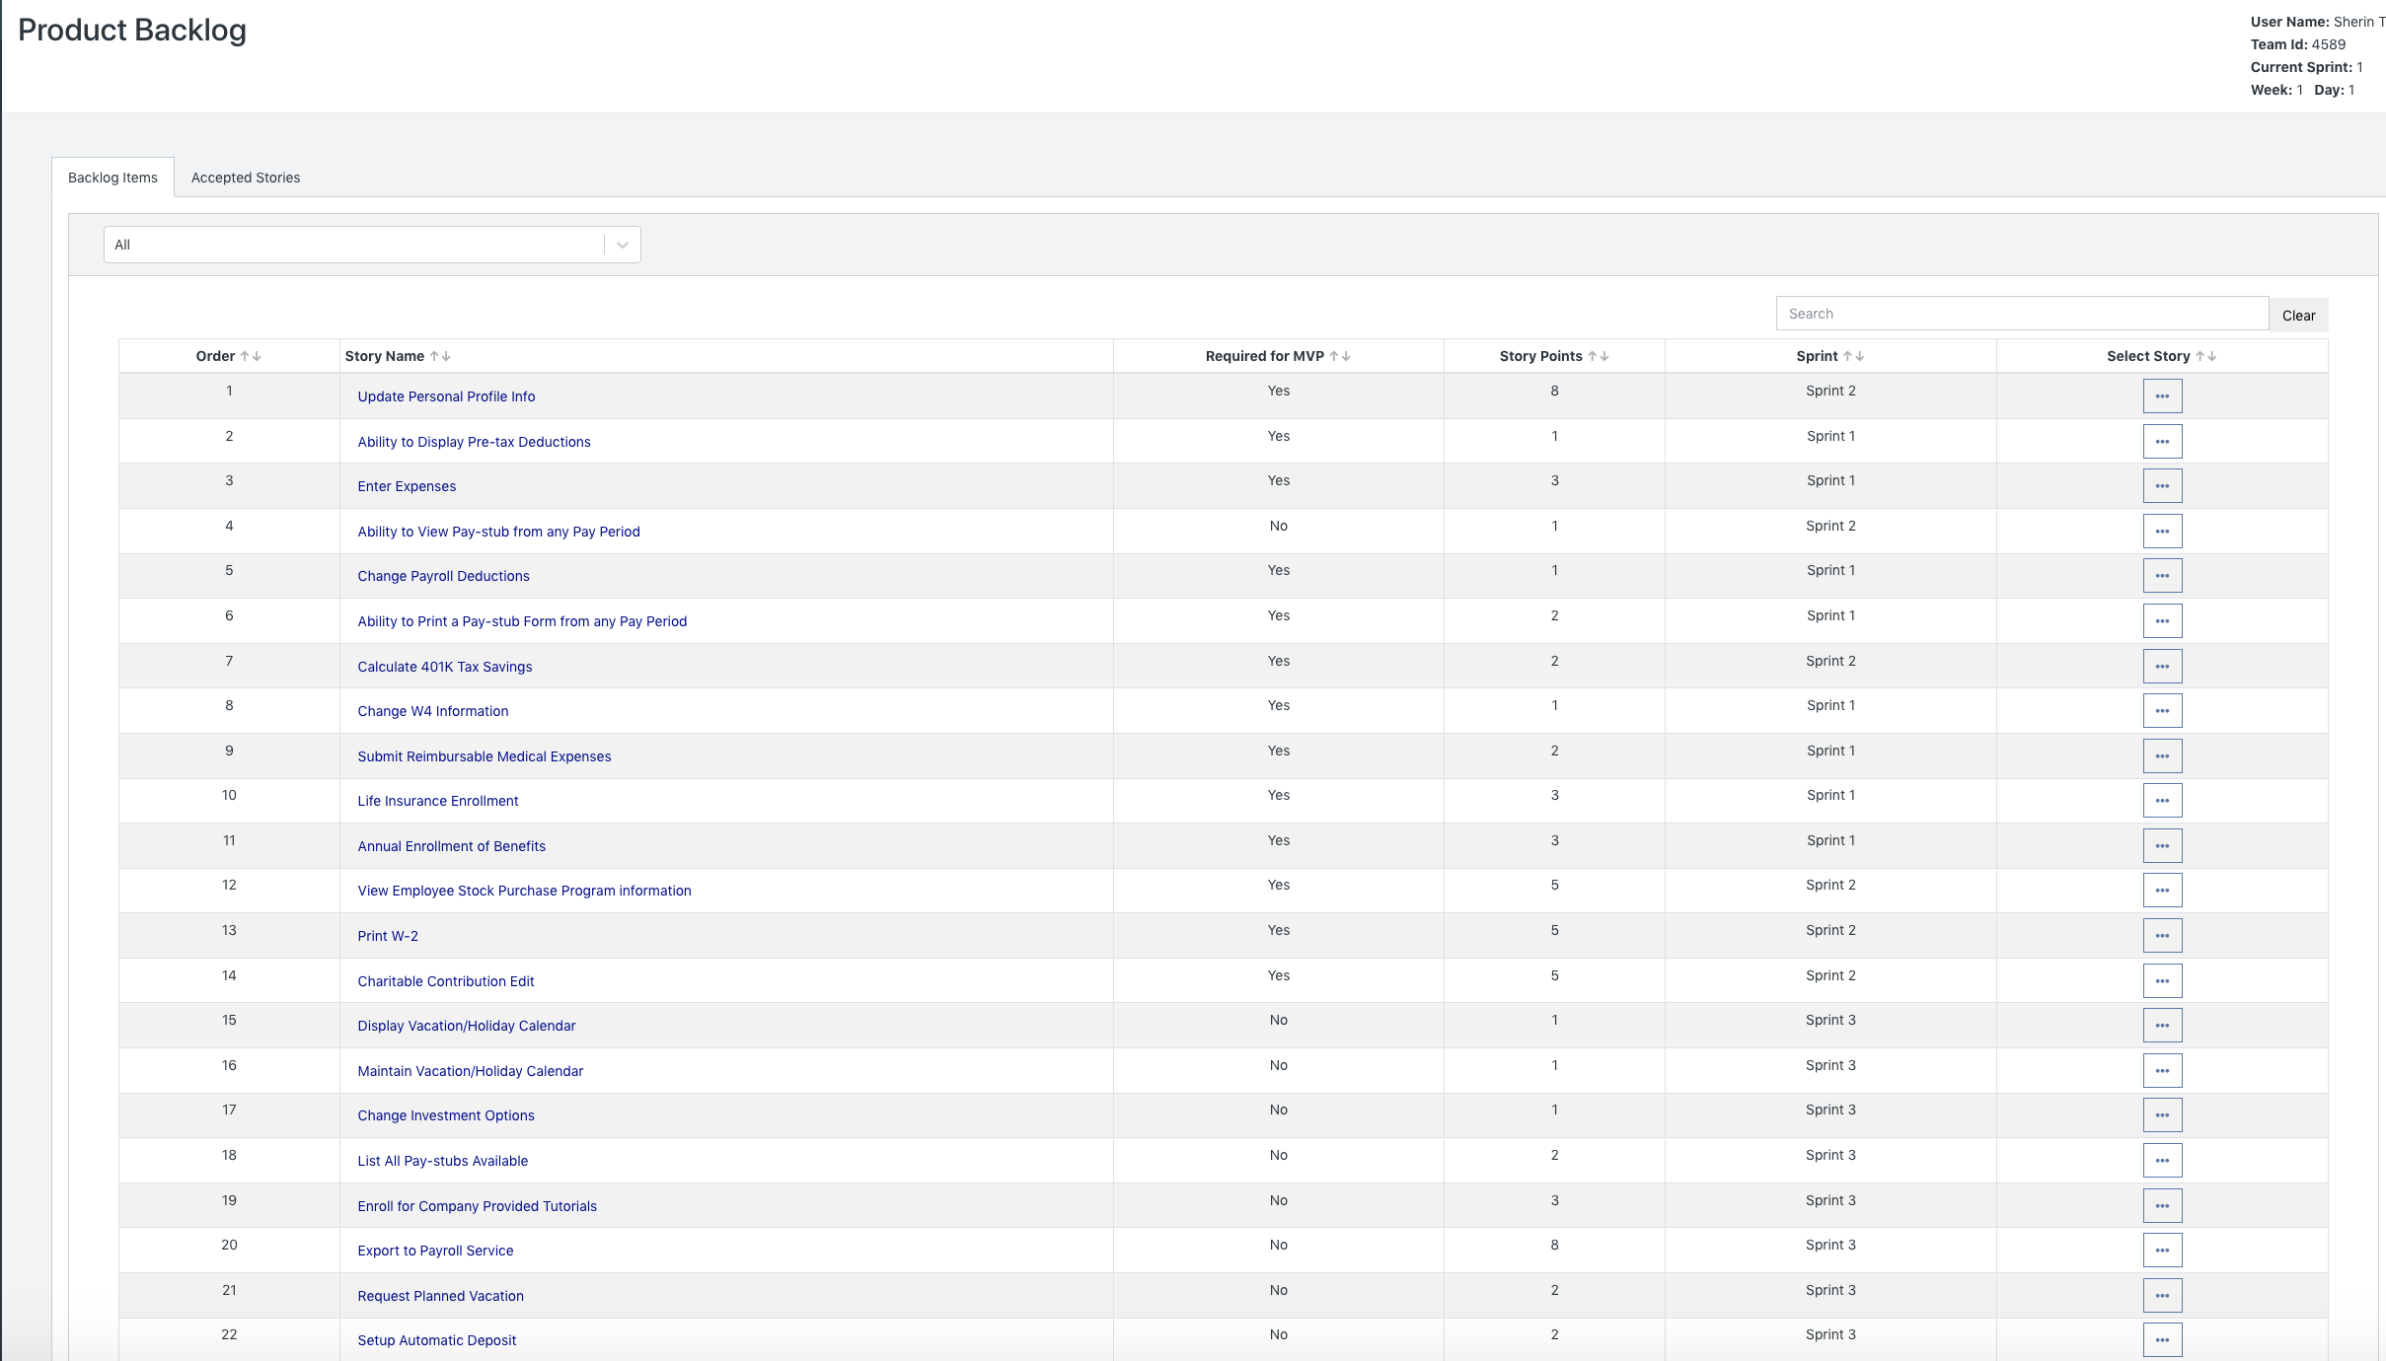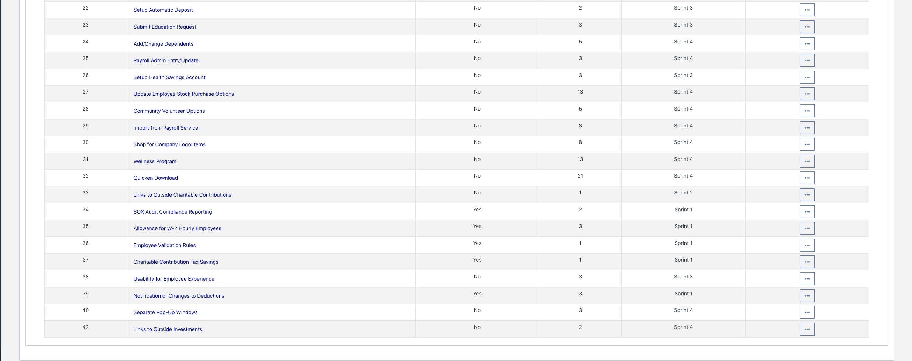

* Please explain what you did in grooming the user stories in your product backlog and your reasoning for these decisions.

Based on last week’s release plan:

* + Sort user stories by MVPs (Z-->A)
    - We wanted to ensure that the MVP is delivered as soon as possible, and thus we wanted to focus on user stories pertaining to MVP first. Hence, using the Sort& Filter option in Excel, we placed all MVP user stories at the top.
  + Calculate Business Value per story point
    - We wanted to deliver the most amount business value per story. Hence, we calculated the business value per story point for each user story. (Formula: Total Business Value Point/ Total Story Points)
  + Sort user stories by descending order of Business Values per story point
    - We wanted to complete the user stories with the most amount of business value per user story point first. Using the Sort & Filter option in Excel, we added a second level to the sort, in which after the MVP is sorted, Excel orders the user stories by the most business value per story point at the top, and the lowest at the bottom.
  + Assigning less than 30 story points for the first two sprints
    - We noticed how the MVP is mostly completed in the first two sprints. However, we did not want to maximize velocity (30 story points) in the first two sprints since we do not want to overload the developers with user stories. Moreover, we wanted to provide a buffer in case there are any issues when developing the MVP user stories. Hence, to sprint 1 we assigned 27 user stories and to sprint 2 we assigned 29 user stories.
  + Maximize the velocity for Sprint 3
    - For sprints 3, we tried to maximize velocity by including as many sorted user stories as possible without exceeding the limit of 30 user story points.
  + Add Sprint 5 and Sprint 6 user stories as Sprint 4’s user stories for the purpose of running this simulation.

**Scrum Board**

Scrum Board screen shot before sprint 1 has started

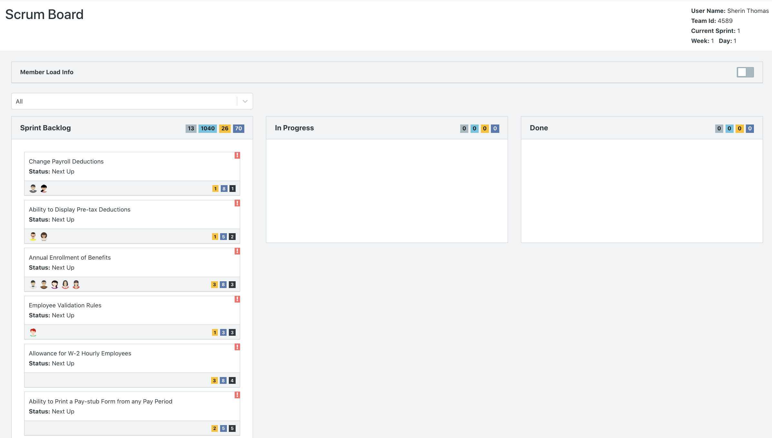

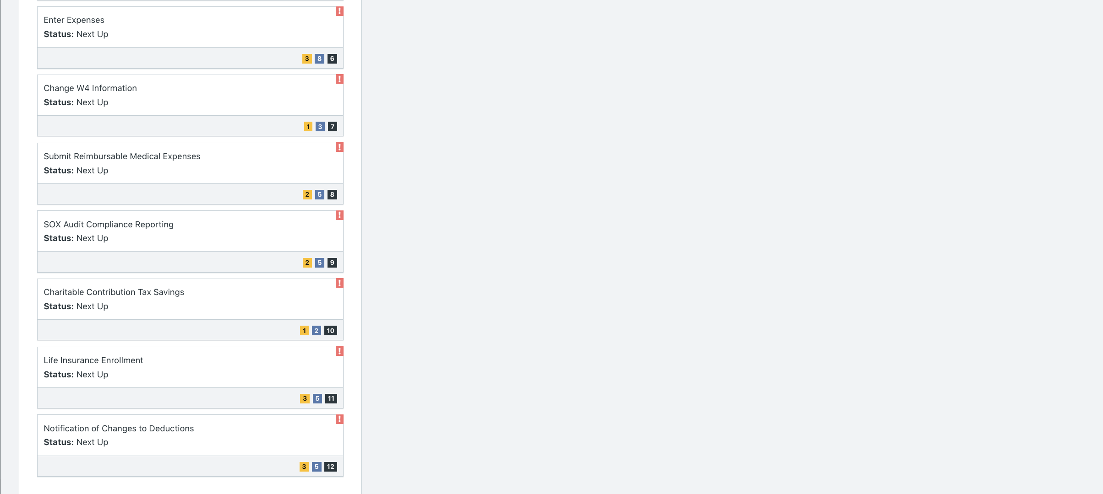

Scrum Board screen shot after 1st week of sprint 1

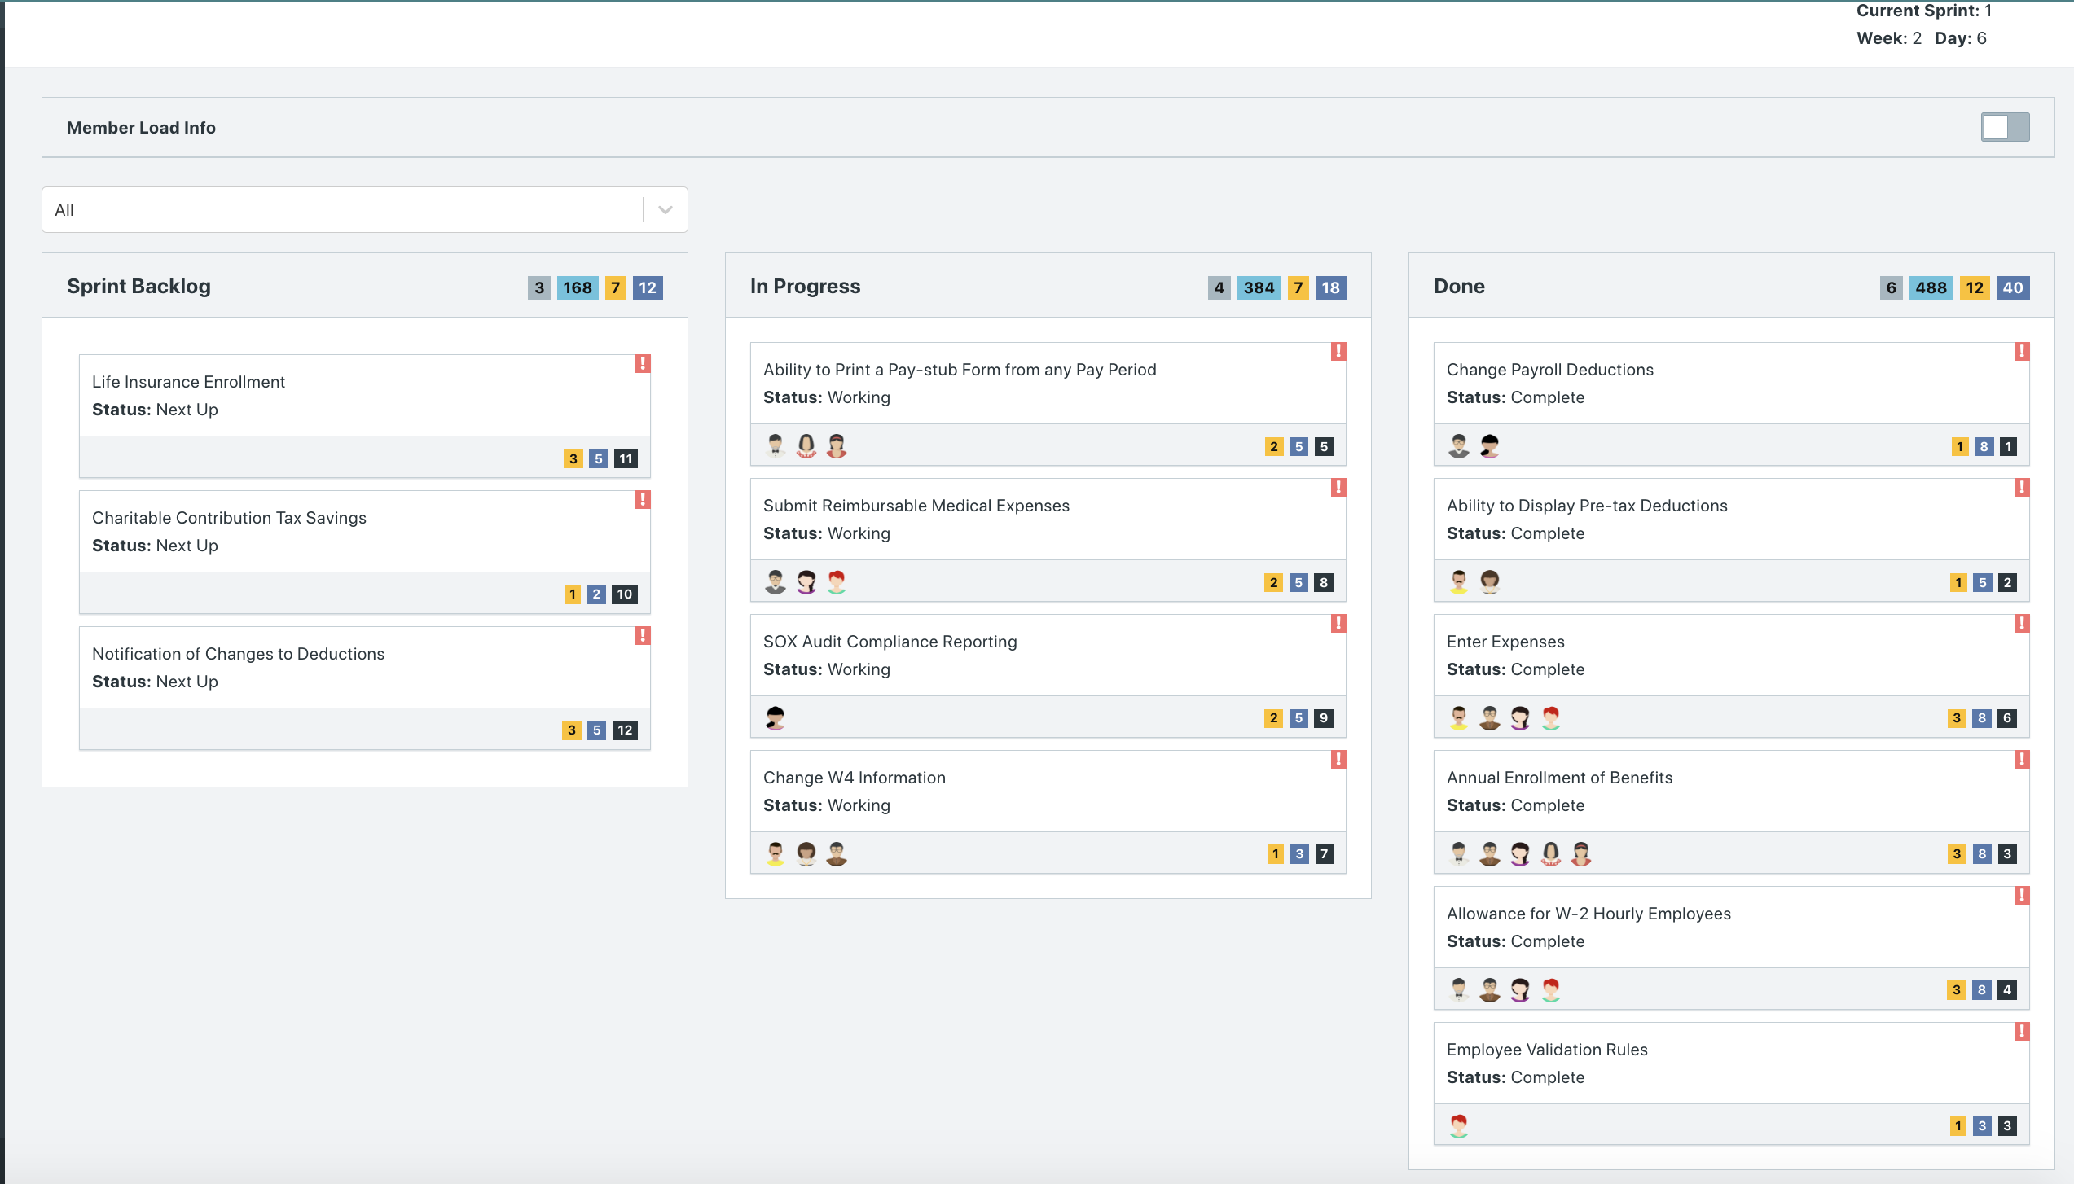

Scrum Board screen shot after 2nd week of sprint 1

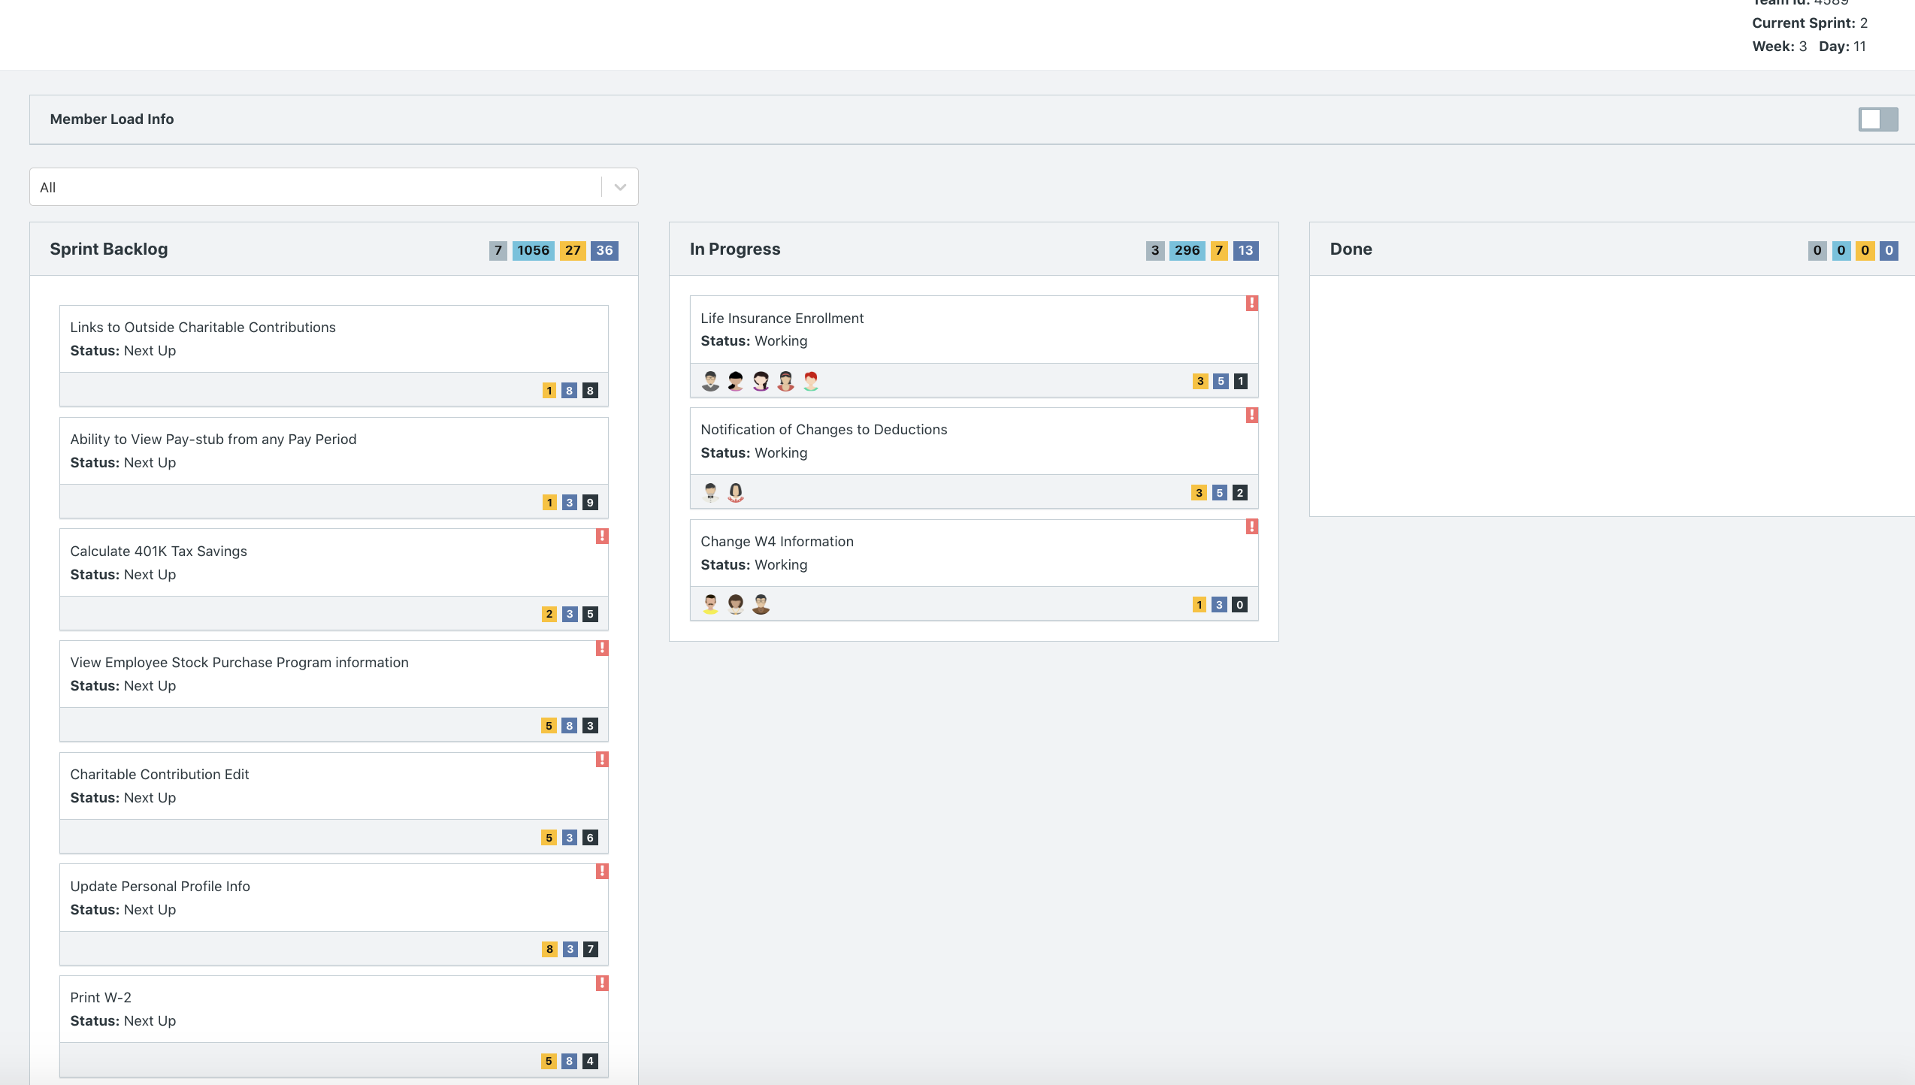

**Calendar**

Paste a screen shot of your calendar for sprint 1

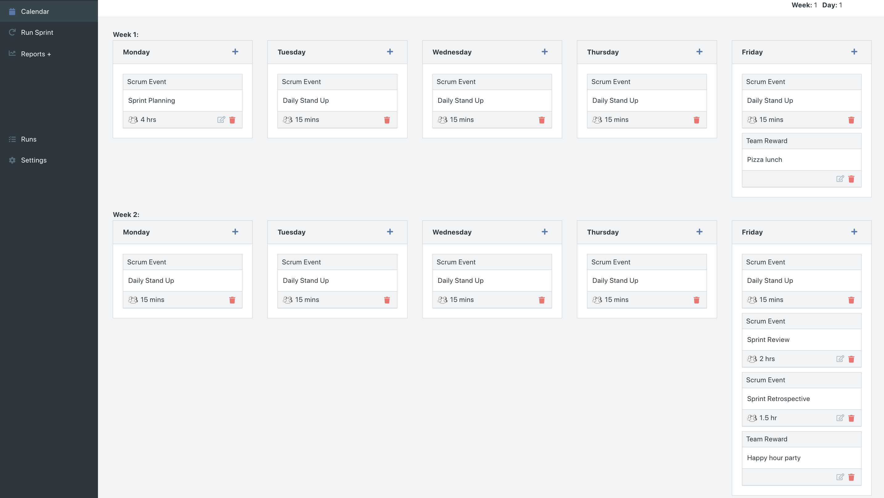

Explain the reason why you have scheduled the meetings listed shown on your calendar.

* We put sprint planning on the first Monday of the sprint since we want to ensure that we plan our sprint before we even start, providing direction of the objectives of the sprint.
* We added Daily Stand Ups on the first Tuesday and every other recurring day after the Sprint. This is to ensure that the team makes time to review what they have completed, what is going to be completed, and the impediments they are facing. Daily Stand Ups are crucial to the agile process.
* We added Sprint Review followed be Sprint Retrospective on the last Friday of the sprint, since we want to review both the completed work and the scrum process at the end of each sprint to make necessary changes before proceeding to the next sprint.
* We added a Pizza Lunch on the first Friday to encourage team bonding, since this may be the first time all the developers are working together.
* We added a Team Happy Hour Party on the last Friday of the Sprint so that team members can celebrate finishing the first sprint of the project and spend time building a relationship with one another.

After competing sprint 1, paste a screen shot of the sprint 1 Burn Down Chart below.

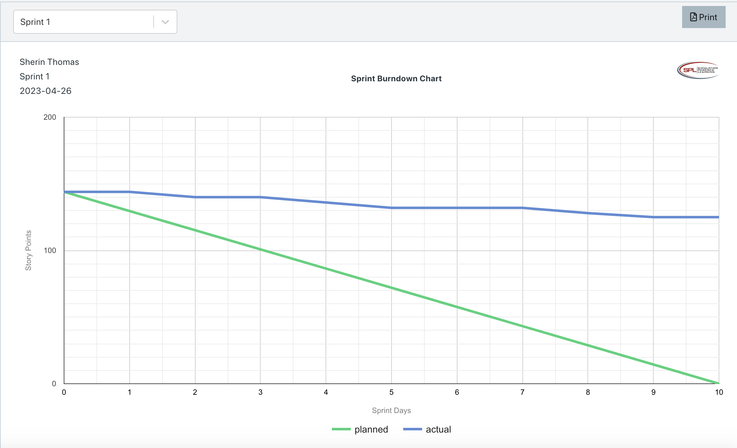

**Velocity Trend**

After competing sprint 1, paste the sprint 1 Velocity Chart below:

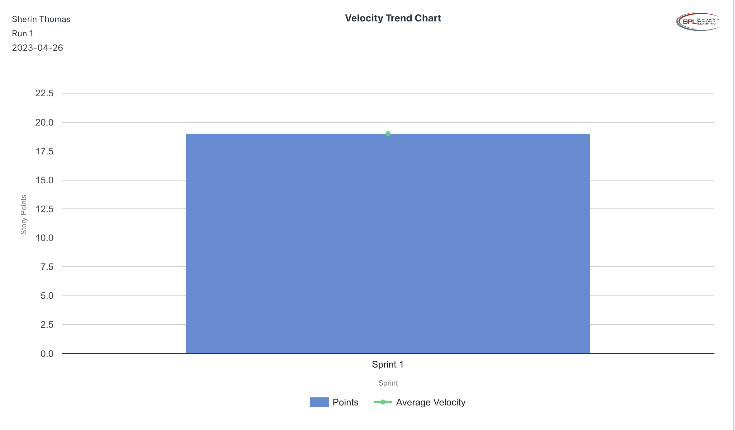

**Retrospective Meeting:**

How did you do in this Sprint?

* We only completed 19 story points out of the 26 story points we planned to complete in Sprint 1. Hence, on a scale of 1-5, we rate 3 for this Sprint because we completed around 70% of the planned story points for Sprint 1.

What problems, if any, did you encounter as you were executing the sprint?

* Developers were absent for: one-on-one sessions, Daily Stand Ups, and the Sprint Retrospective.
* It was reported that team morale and energy was low.

What changes, if any, are you are planning to make in the next sprint?

* After the issue of the Daily Stand Up being too early in the morning was brought on by multiple developers, we agreed to change the time of the Daily Stand Up to later in the day.
* To increase morale, we are going to schedule more individual and team rewards in Sprint 2’s calendar.
* To relieve the issue of multiple absences for one-on-one sessions, daily stand ups, and the sprint retrospective, we are going to add a 1-day Agile Bootcamp for the whole team. We are hoping this bootcamp will highlight the importance of attending scrum activities.

**Answer following questions based on this Sprint:**

What is the velocity (in story points) for the sprint?

* 19 story points

What is the average velocity, minimum velocity, and maximum velocity (in story points) for the project across all sprints that have been completed so far?

* Because this is Sprint 1, we do not have data from other sprints to calculate total average, minimum, and maximum velocity.

Based on the current status of your project, do you believe that you will be able to complete the mandatory (or required) stories in the product backlog within the four sprints?  Explain your answer.

* We do believe that we will be able to complete the mandatory stories in four sprints. This is because our initial release plan estimated to release the MVP by Sprint 2. With the rate we are going at currently, even though we only completed around 70% of the story points assigned for Sprint 1, we can still finish the MVP by Sprint 4. Furthermore, because this is Sprint 1, we are learning the dynamics and performance of our team; based on the feedback in the reviews and retrospectives, we can address the issues and in return achieve better results in each following Sprint.

Based on the current status of your project, do you believe that you will be able to complete all stories in the product backlog within the four sprints planned? Explain your answer.

* Our developers have not been able to complete all the user stories necessary for Sprint 1, meaning we are currently behind schedule. Hence, based on the velocity of Sprint 1, we believe we will not be able to complete all stories in the PBI within four sprints.

**Sprint 2 - Week 3 and Week 4 (10 Points)**

**Product Backlog (one screen shot for the sprint)**

Paste the screen shot of your Product Backlog below.

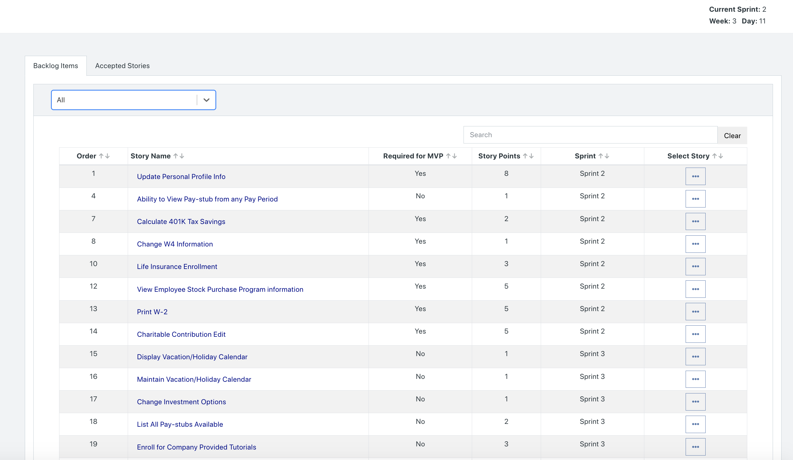

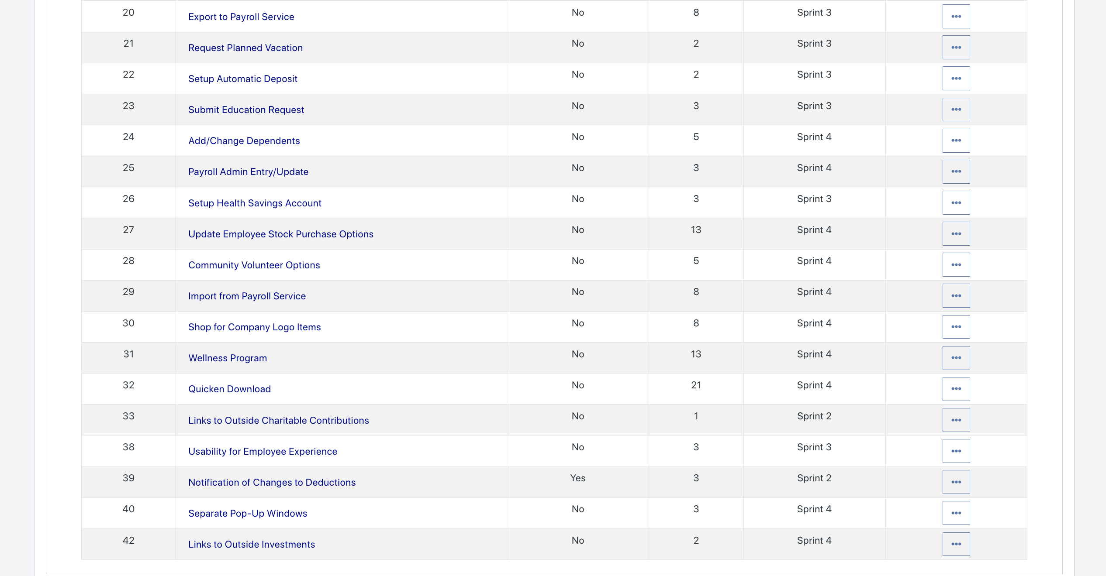

Please explain what you did in grooming the user stories in your Product Backlog and your reasoning for these decisions.

* For Sprint 2’s execution, we did not change the order of any user stories. Rather, we kept the user stories assigned to the same sprint as based on our initial release plan from last week.

**Scrum Board**

Scrum Board screen shot before sprint 2 has started

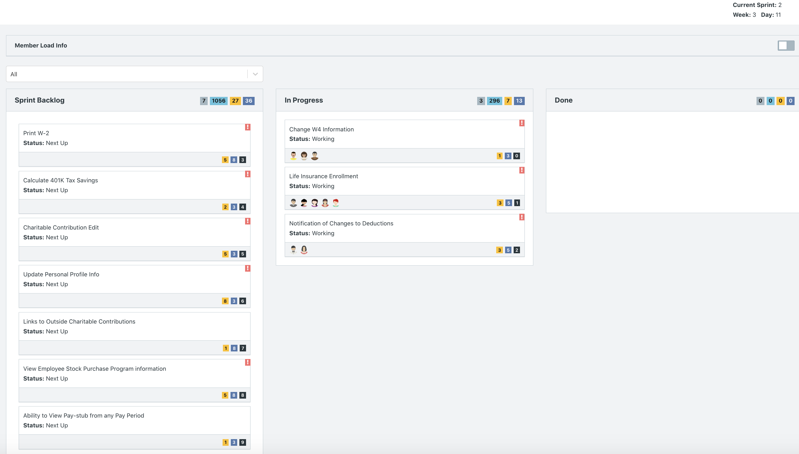

Scrum Board screen shot after 1st week of sprint 2

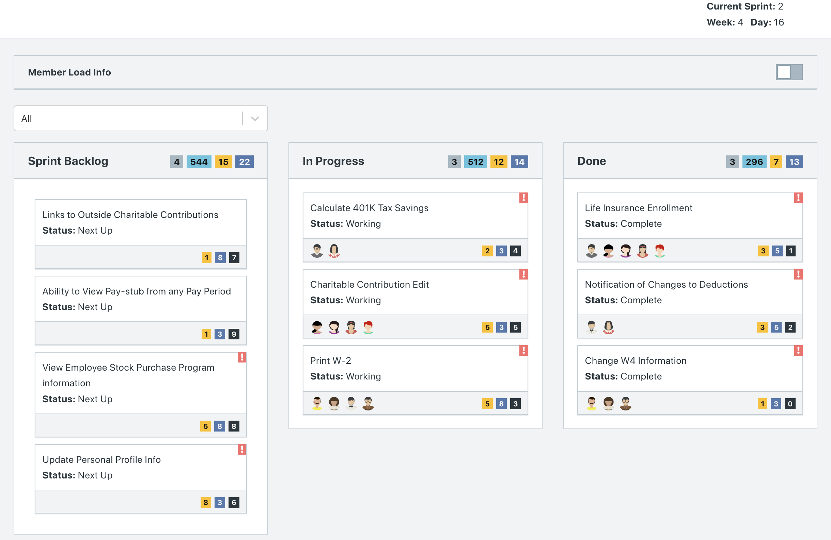

Scrum Board screen shot after 2nd week of sprint 2

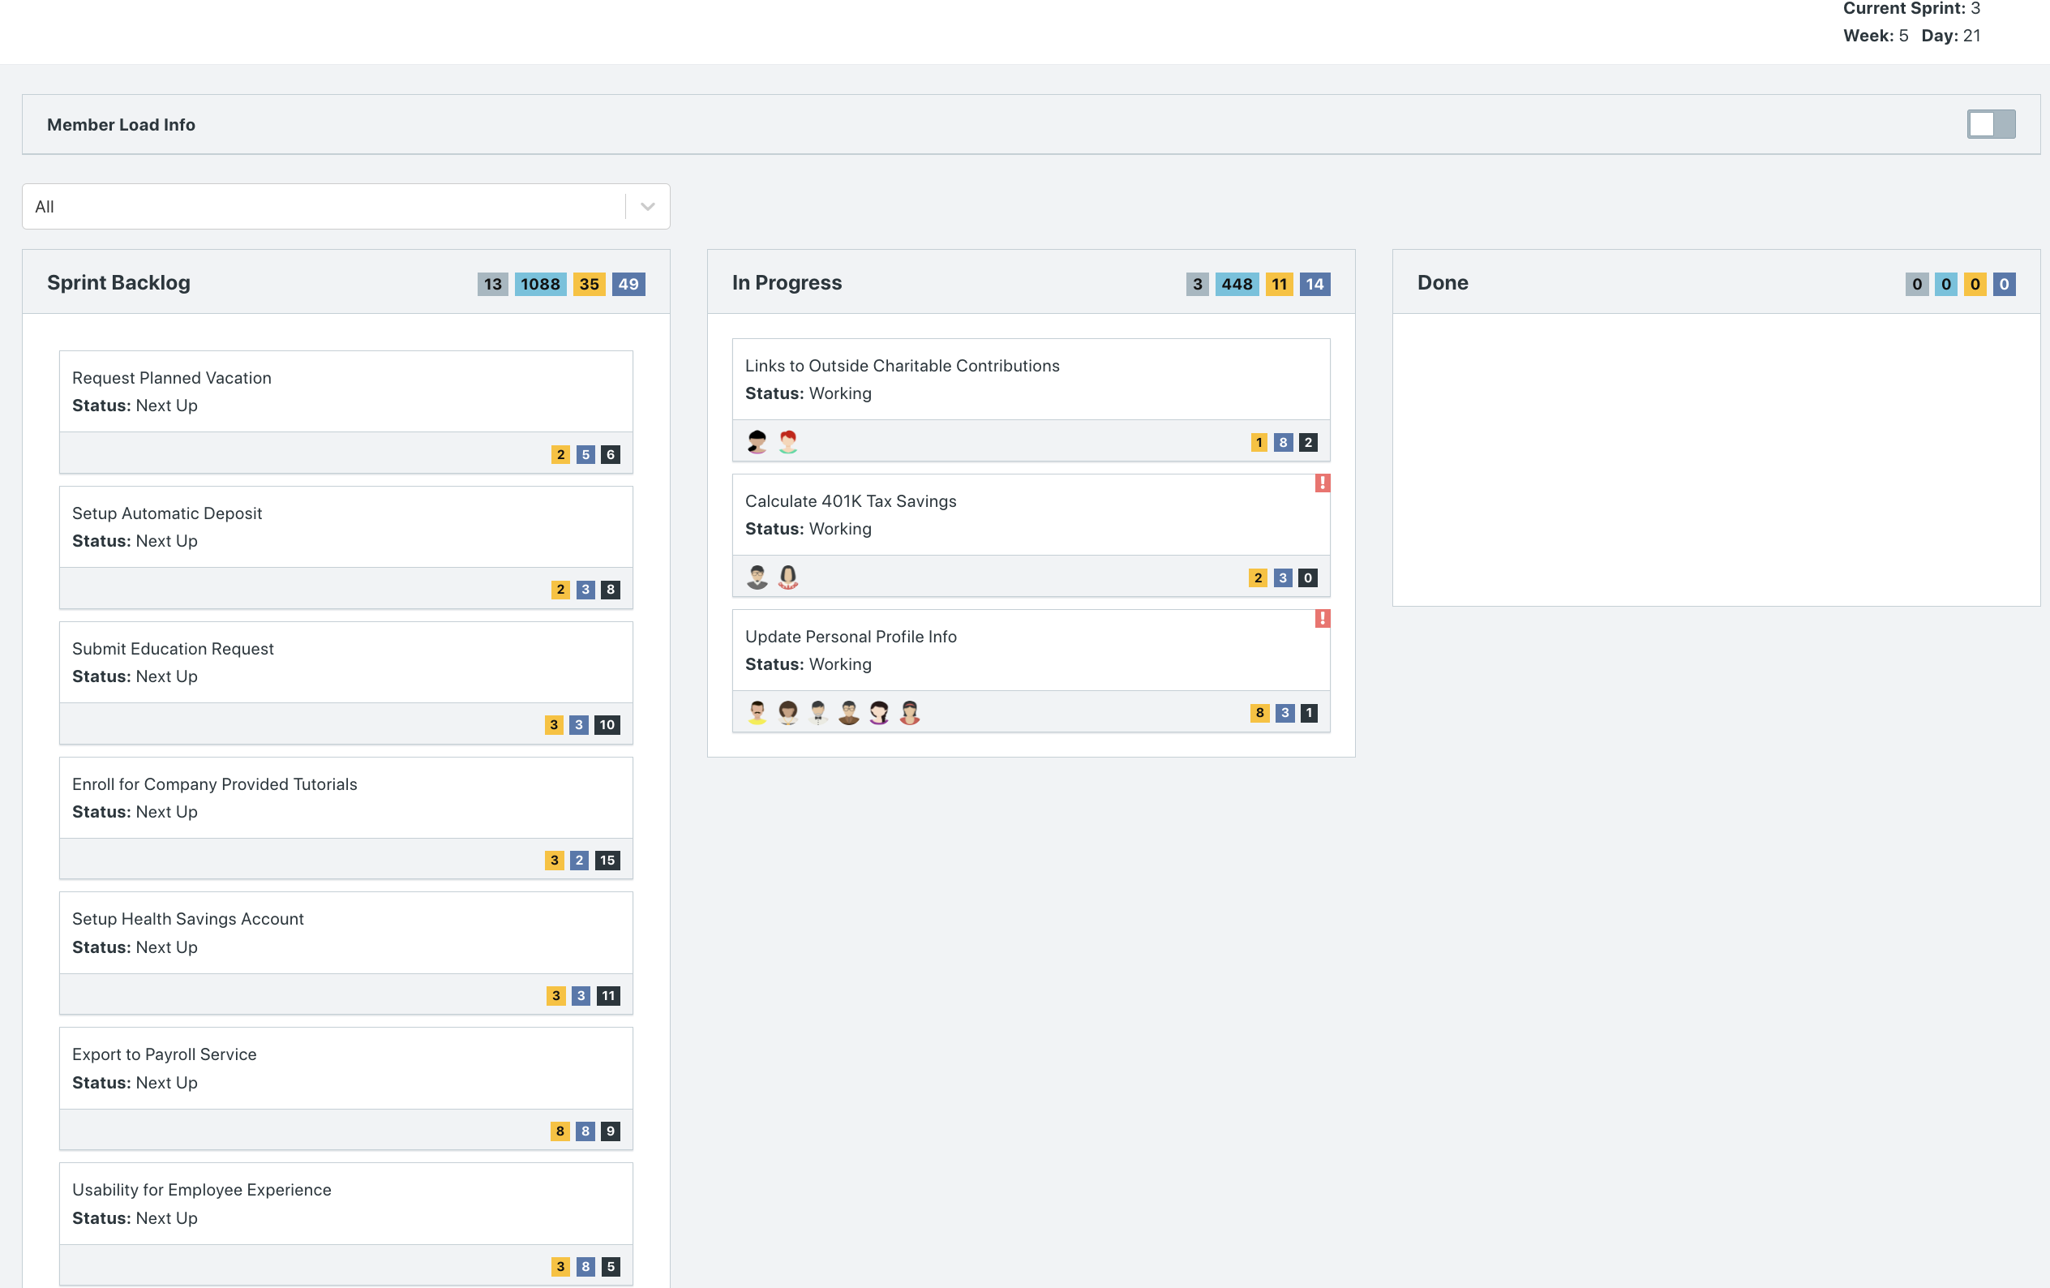

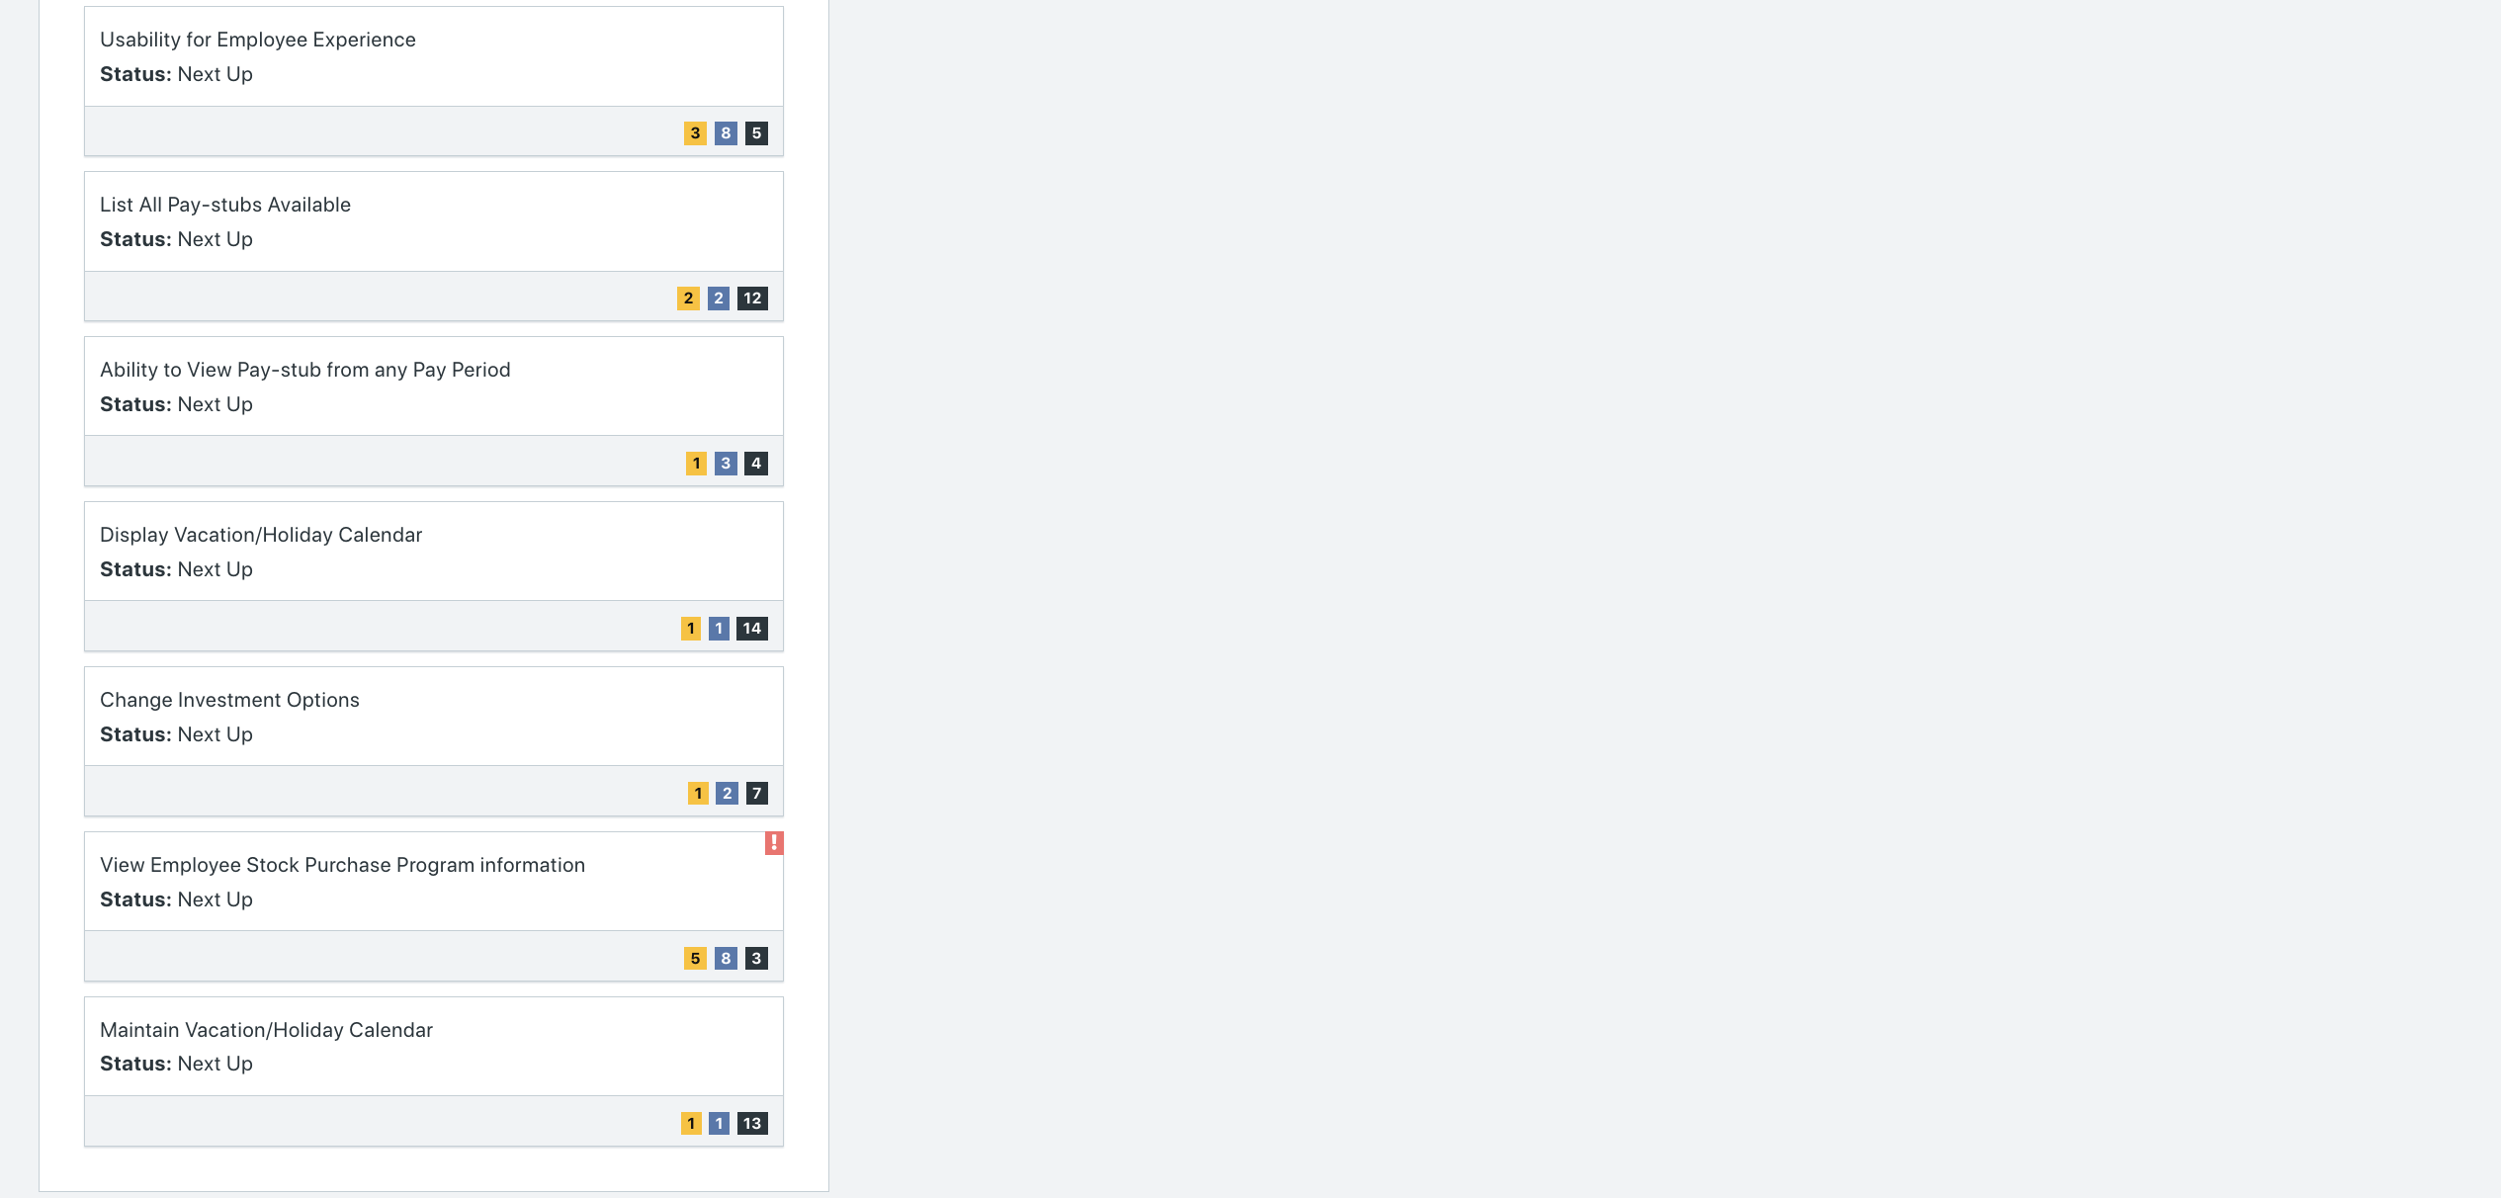

**Calendar**

Paste the screen shot of your calendar for sprint 2

Before running Week 3:

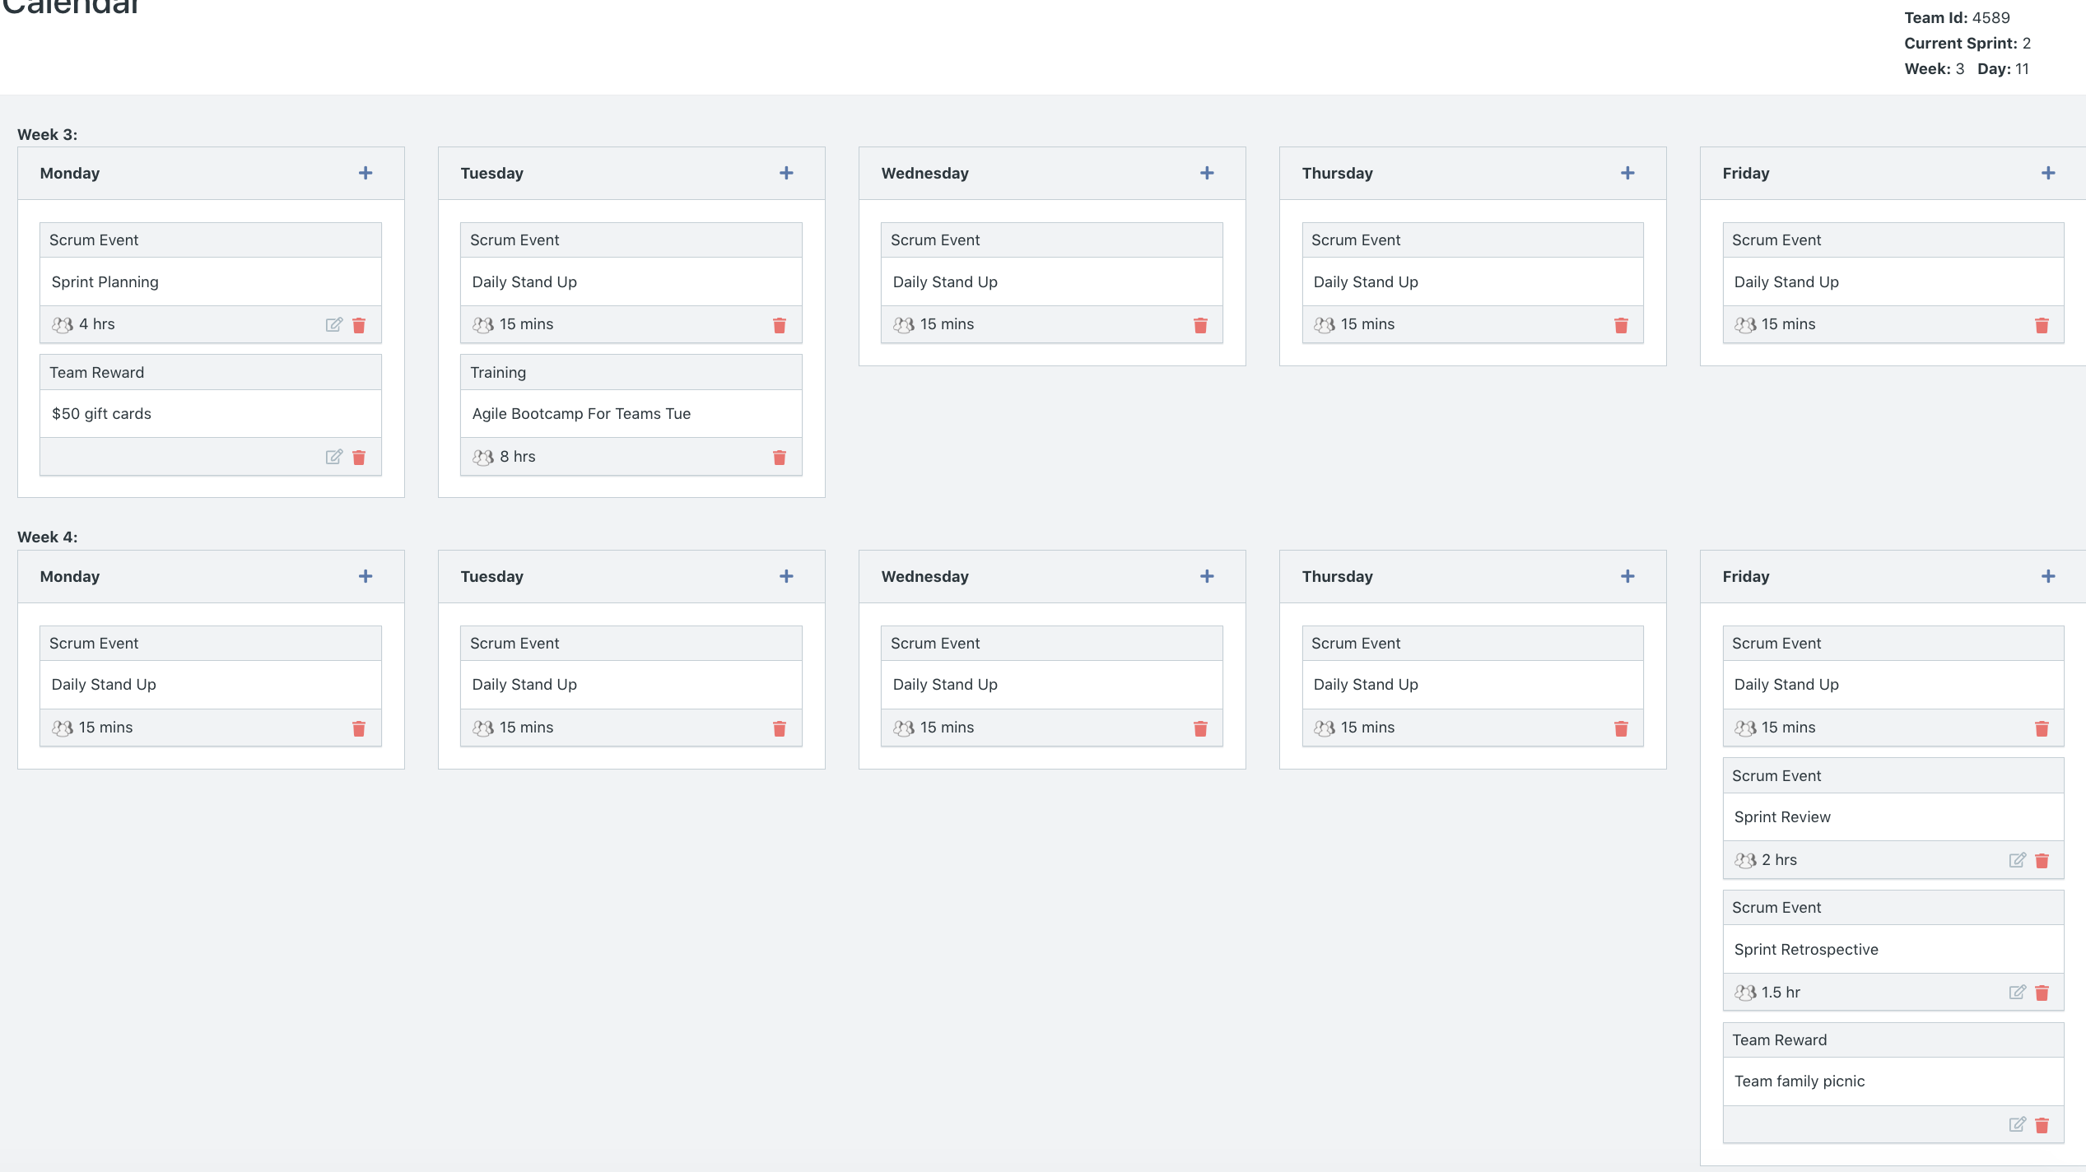

After running Week 3/ Additions to Week 4:

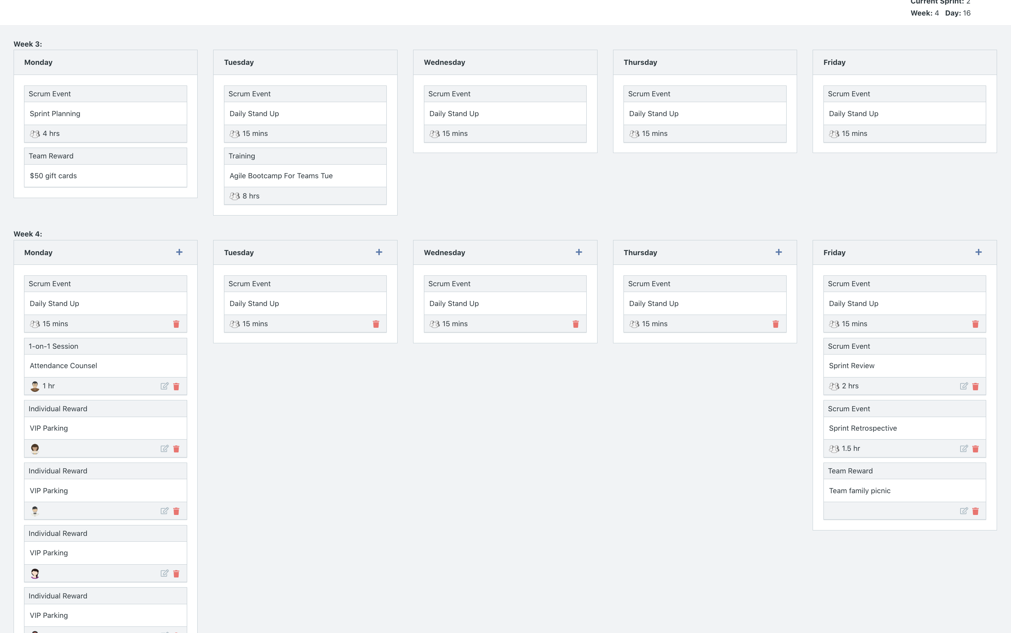

Explain the reason why you have scheduled the meetings listed shown on your calendar (if any)?

* Week 3
  + We added the team reward of $50 gift cards on the first Monday as an incentive to use the money to buy coffee or lunch, which may help developers feel more ready to complete their tasks of the day.
  + We scheduled an Agile Bootcamp (only available on Tuesday) to resolve the issue of the increased number of absences for Daily Stand Ups. We hope the bootcamp will teach our developers the importance of scrum activities.
* Week 4 additions
  + We added a 1-on-1 counseling session for Nick because he had missed more than half of the Daily Stand Ups for the week. We wanted to address the issue and talk to him to decrease the number of absences.
  + After running week 3 of sprint 2, we noticed the number of absences only increased despite the Agile Bootcamp. Hence, we provided an individual reward of VIP Parking on Monday to the developers who missed 2 or less Daily Stand Ups for the week.
  + On Friday, we added a Team Family Picnic to celebrate the end of Sprint 2 but also provide an opportunity for team relationship building.

**BurnDown**

After competing sprint 2, paste a screen shot of the sprint 2 Burn Down Chart below.

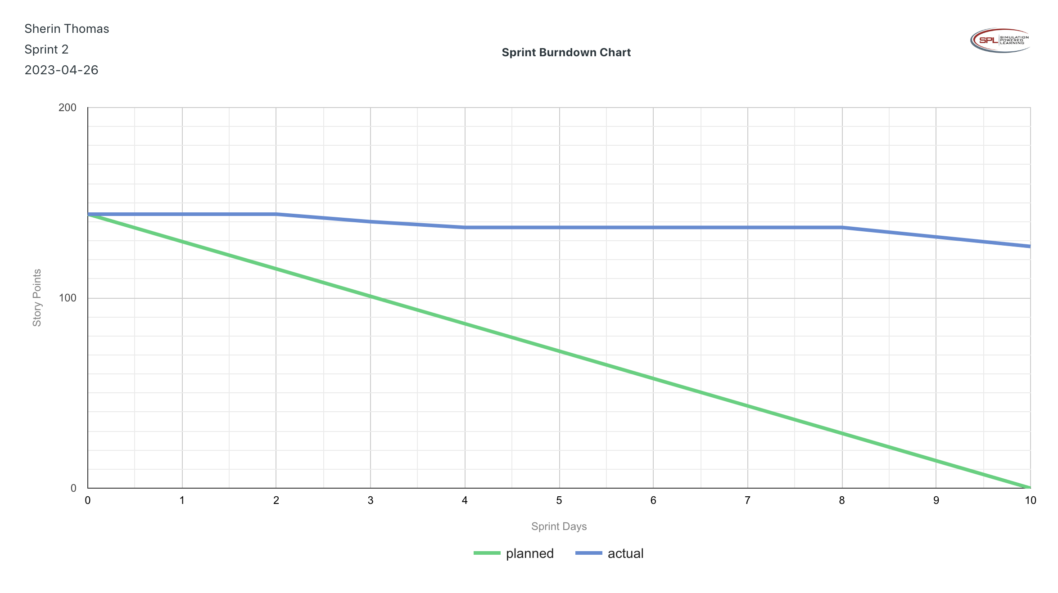

**Velocity Trend**

After competing sprint 2, paste the sprint 2 Velocity Chart below:

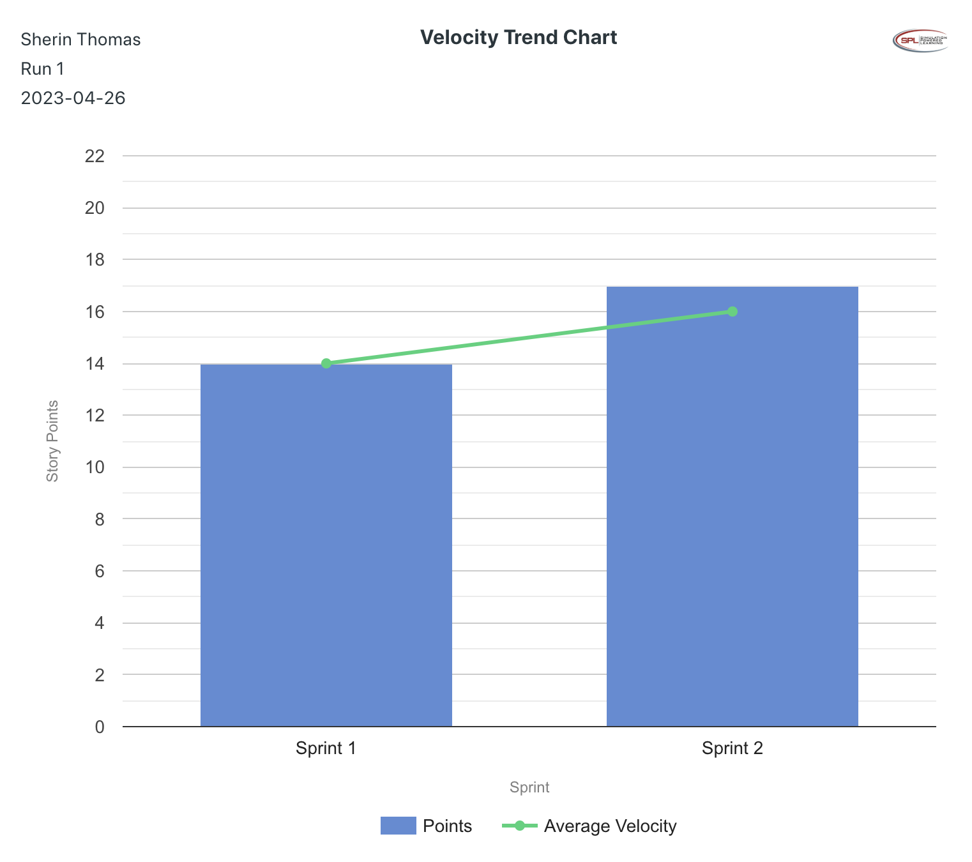

**Retrospective Meeting:**

How did you do in this Sprint?

* We had 7 story points remaining from Sprint 1 plus the 27 story points planned for Sprint 2, resulting in a total of 34 planned story points. However, in Sprint 2 we only completed 17 story points, which is 50% of what we planned. Hence, on a scale from 1-5, we rate Sprint 2 as a 2.

What problems, if any, did you encounter as you were executing the sprint?

* Developers still were not attending daily scrum.
* Developers scheduled for one-on-one sessions skipped the meetings.
* Developers are not being able to complete the required Sprint story points as expected.
* At the end of Week 4, when looking at Member Load, it seems that certain developers are overallocated in the number of hours they can work.

What changes, if any, are you are planning to make in the next sprint?

* Add a one-on-one session with warnings for the developers who are missing Daily Stand Ups more than twice a week.
* Add a Backlog Refinement to the following Sprint. From now on we will need to rearrange the user stories planned per sprint since we are behind schedule.

**Answer following questions based on this Sprint:**

What is the velocity (in story points) for the sprint?

* 17 points

What is the average velocity, minimum velocity, and maximum velocity (in story points) for the project across all sprints that have been completed so far?

* Average Velocity: 18 points
* Minimum Velocity: 17 points
* Maximum Velocity: 19 points

Based on the current status of your project, do you believe that you will be able to complete the mandatory (or required) stories in the product backlog within the four sprints?  Explain your answer.

* Out of the 18 user stories required for MVP, we currently have completed 10 user stories. Hence, based on the current velocity of Sprint 1 & 2 and the fact that we only have 8 MVP user stories that need be completed before the end of Sprint 4, we believe we will be able to complete the MVPs within four sprints.

Based on the current stats of your project, do you believe that you will be able to complete all stories in the product backlog within the four sprints planned? Explain your answer.

* Our developers have not been able to complete all the user stories necessary for Sprint 1 or Sprint 2, meaning we are currently behind schedule. Hence, based on the velocity of Sprint 1 and 2, we believe we will not be able to complete all stories in the PBI within four sprints.

**Sprint 3 - Week 5 and Week 6 (10 Points)**

**Product Backlog (one screen shot for sprint 3)**

Paste the screen shot of your product backlog below.

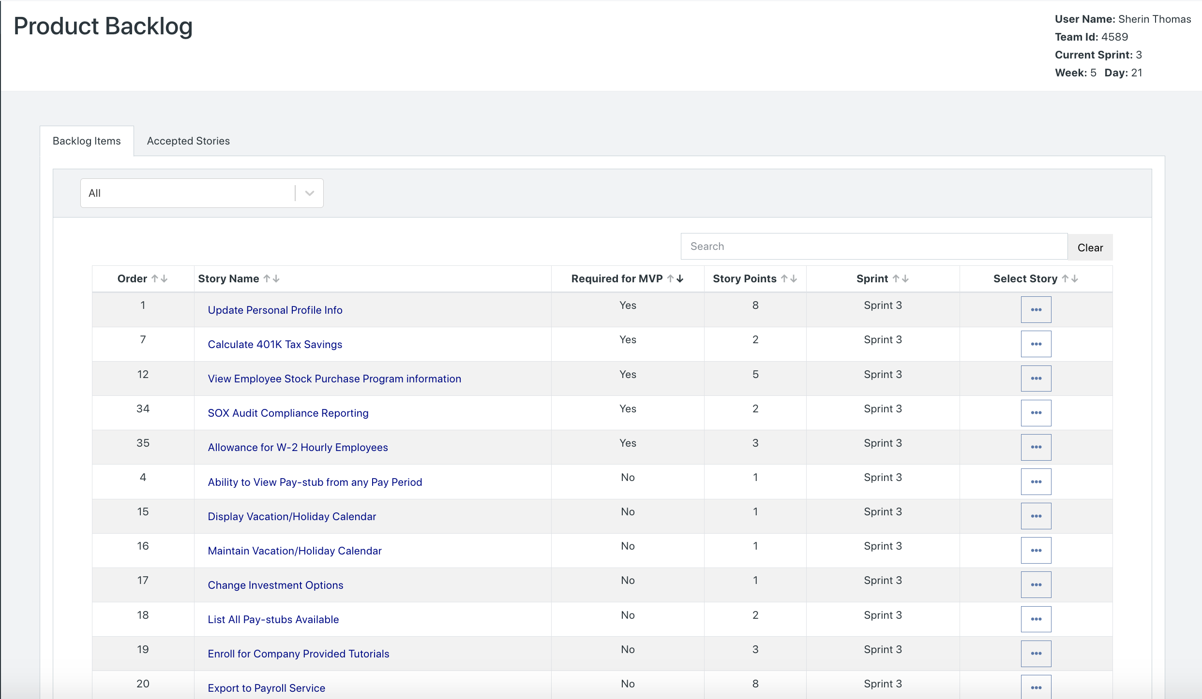

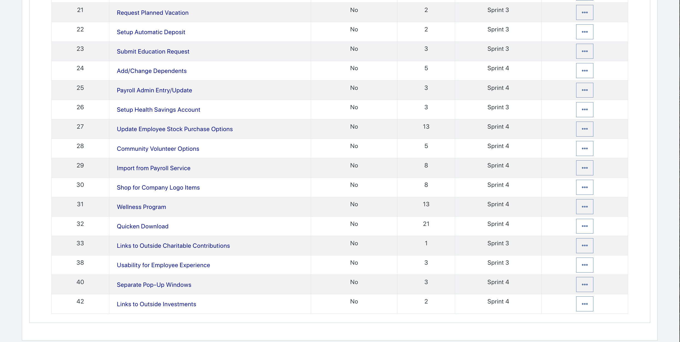

Please explain what you did in grooming the user stories in your Product Backlog and your reasoning for these decisions.

* We moved two of the uncompleted MVP user stories in Sprint 1 to Sprint 3's Product Backlog, which already had three MVP user stories in it.. We did this to attempt to complete the remaining 5 MVP user stories in Sprint 3, rather than backlog them any further. In the Scrum Board, we put all MVP user stories as first priority.

**Scrum Board**

Scrum Board screen shot before sprint 3 has Started

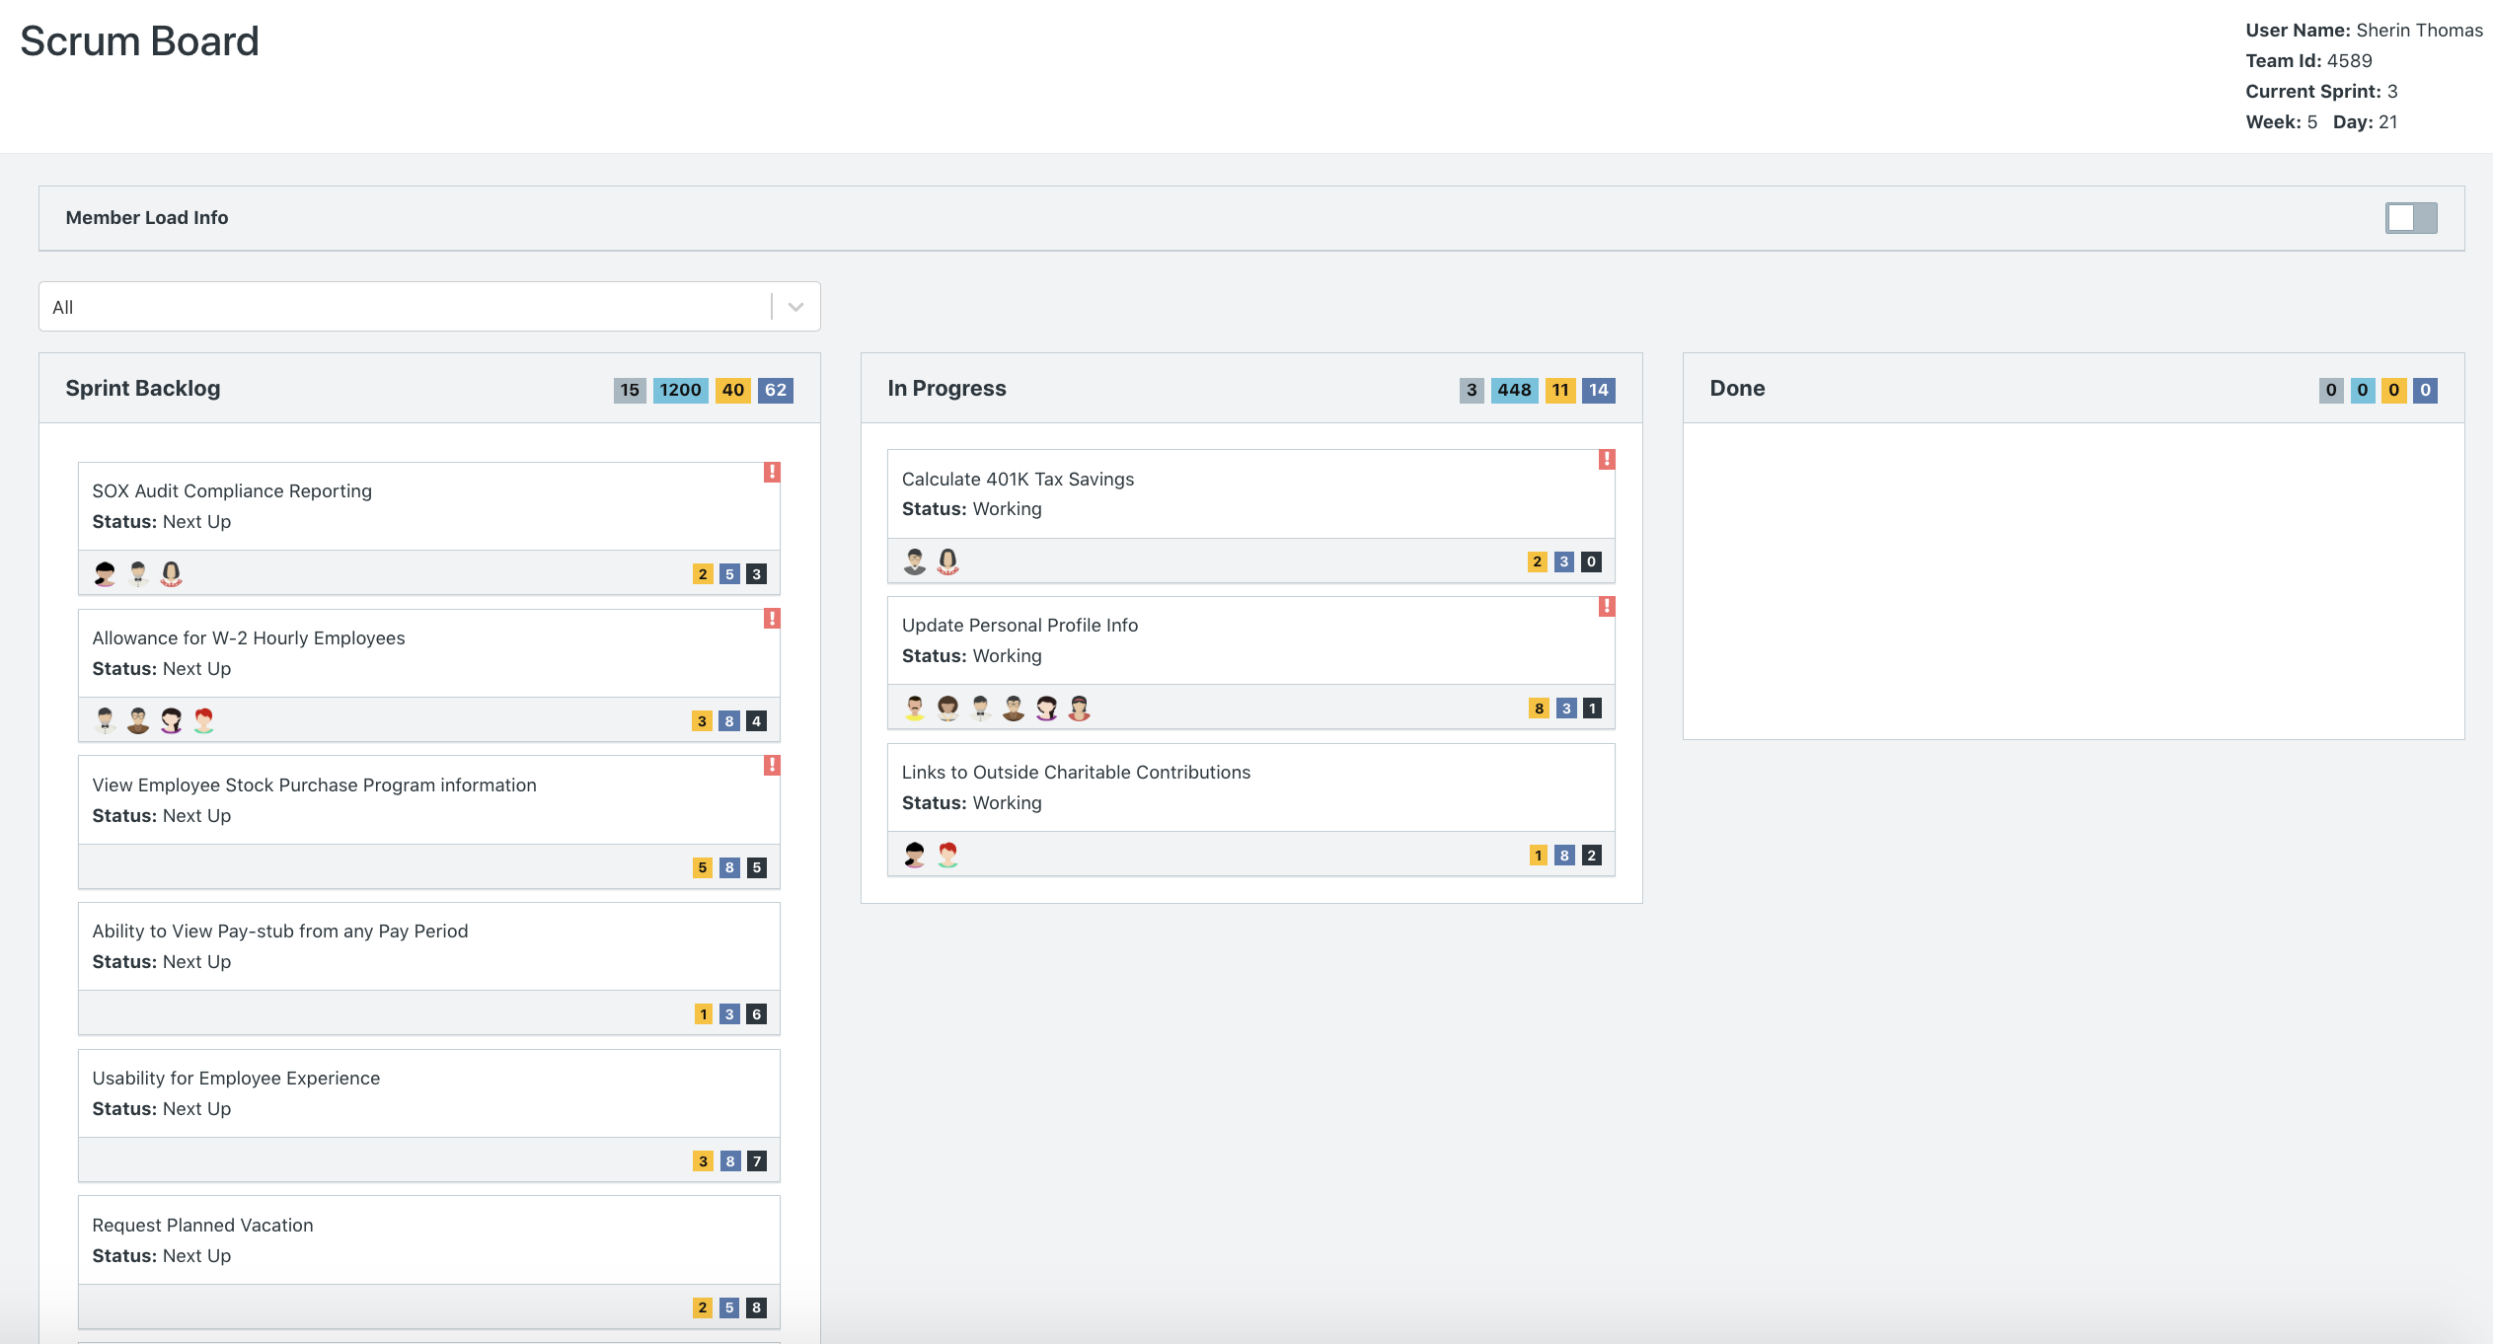

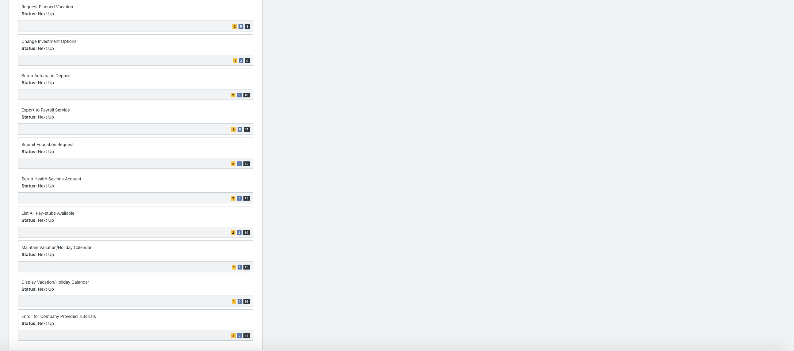

Scrum Board screen shot after 1st week of sprint 3

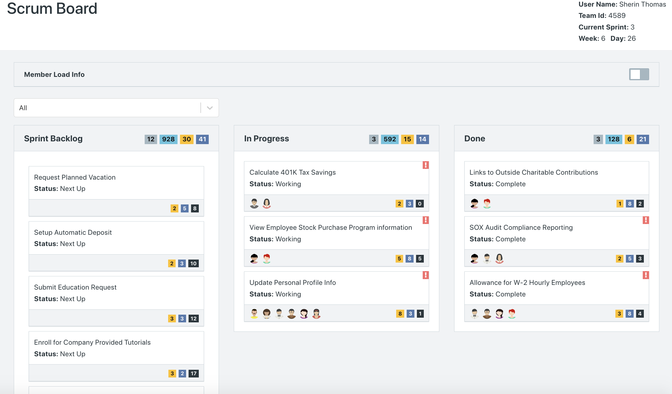

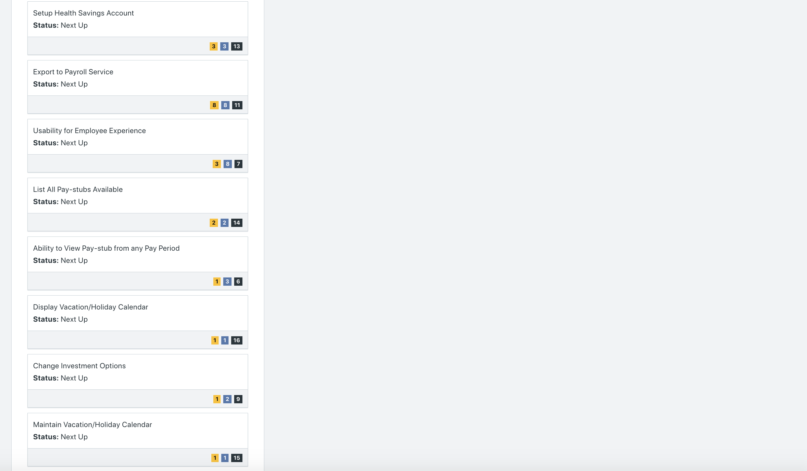

Scrum Board screen shot after 2nd week of sprint 3

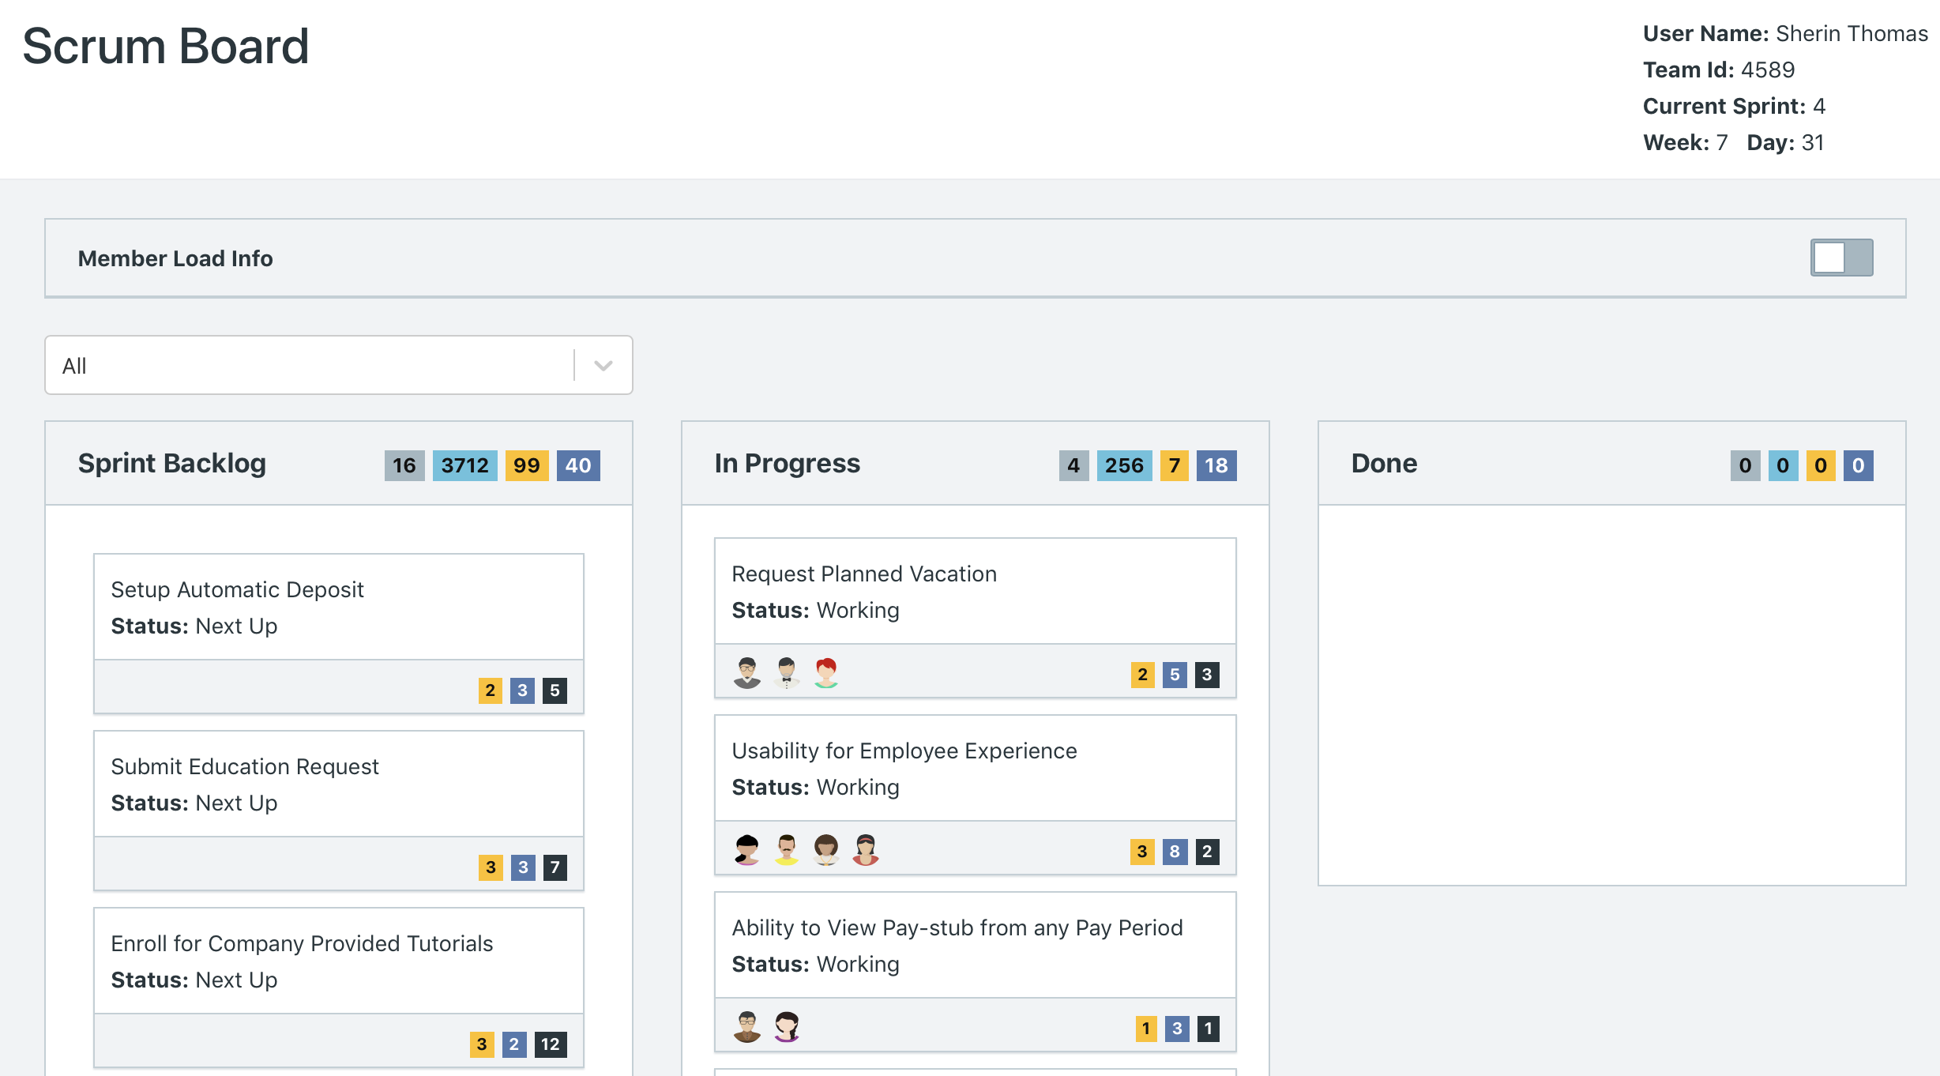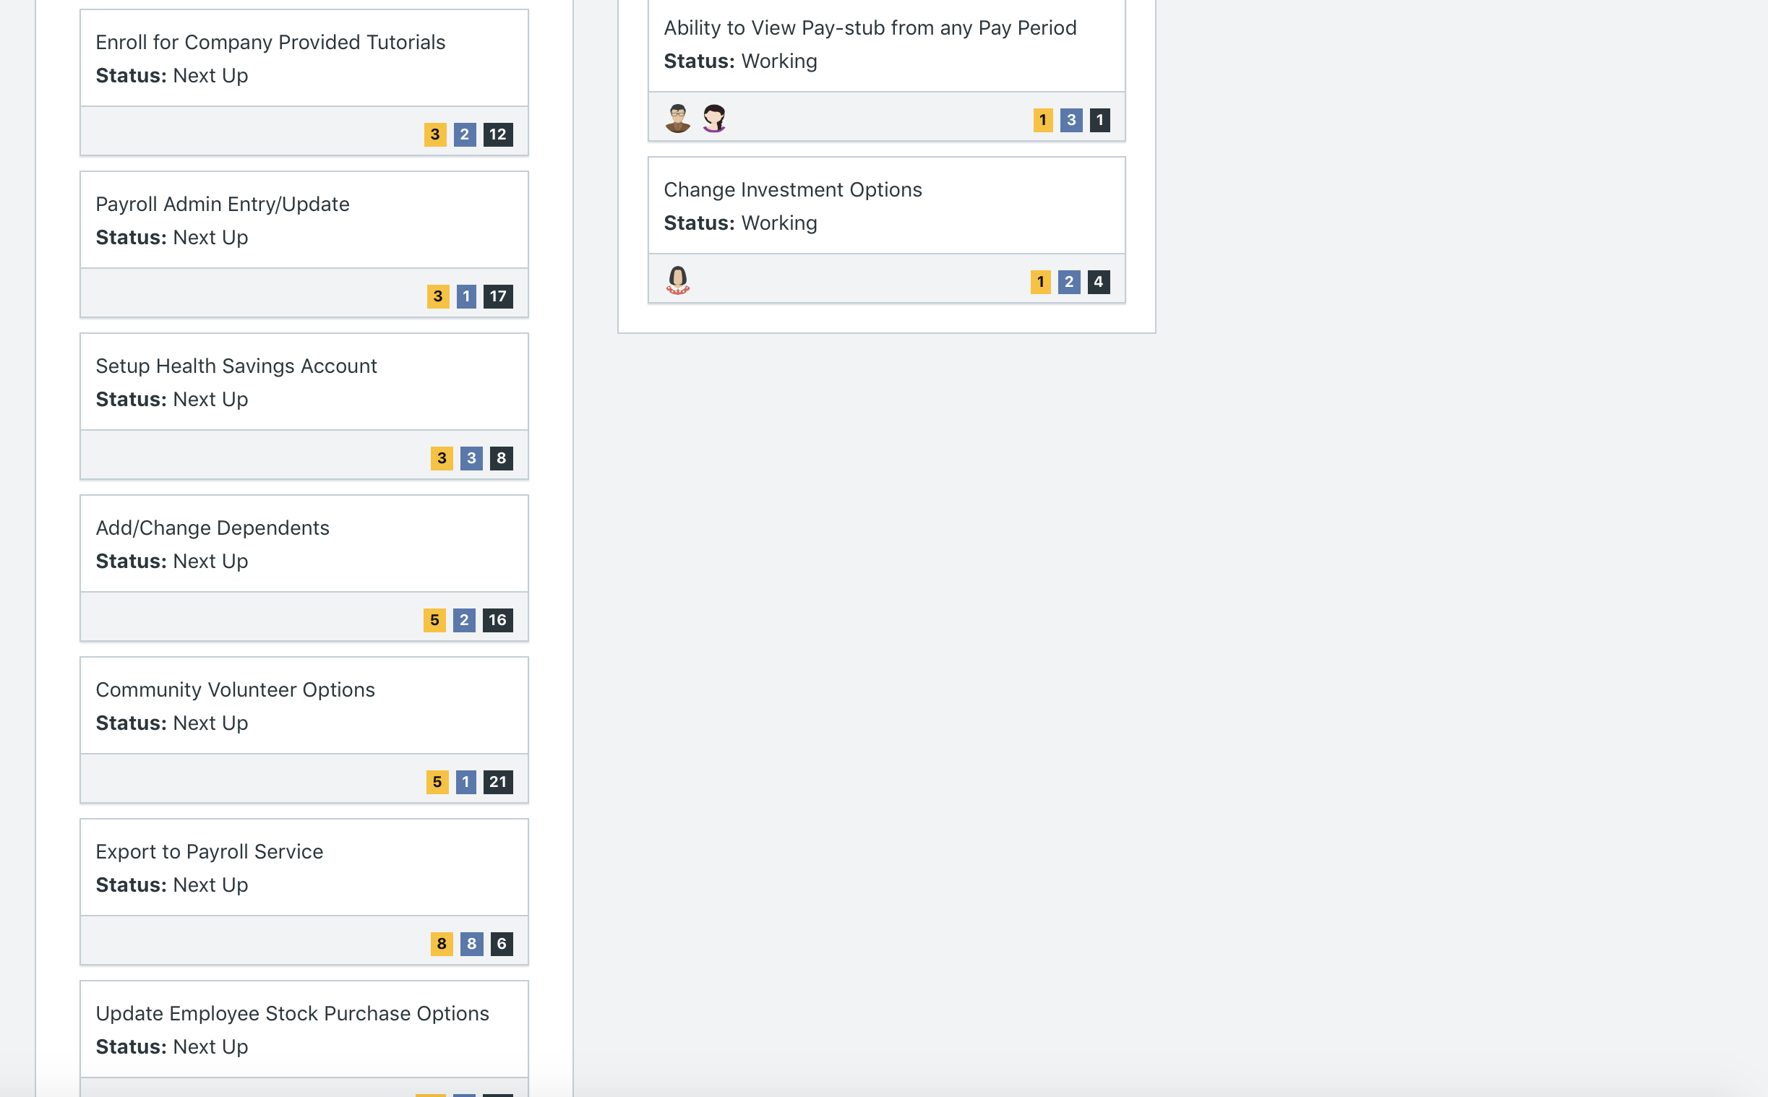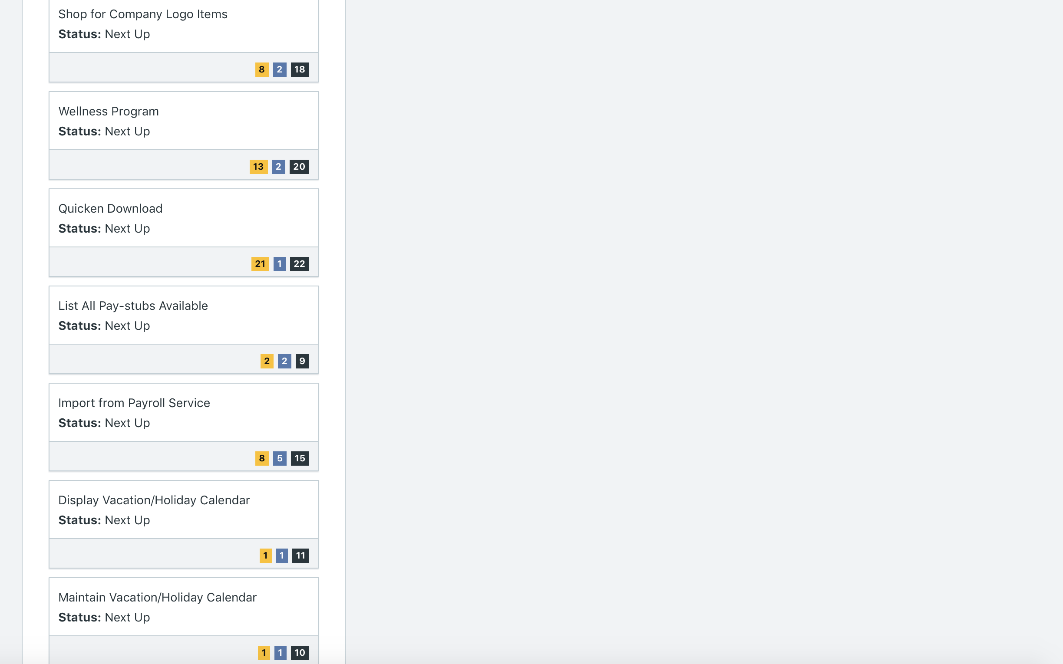

**Calendar**

Paste the screen shot of your calendar for sprint 3

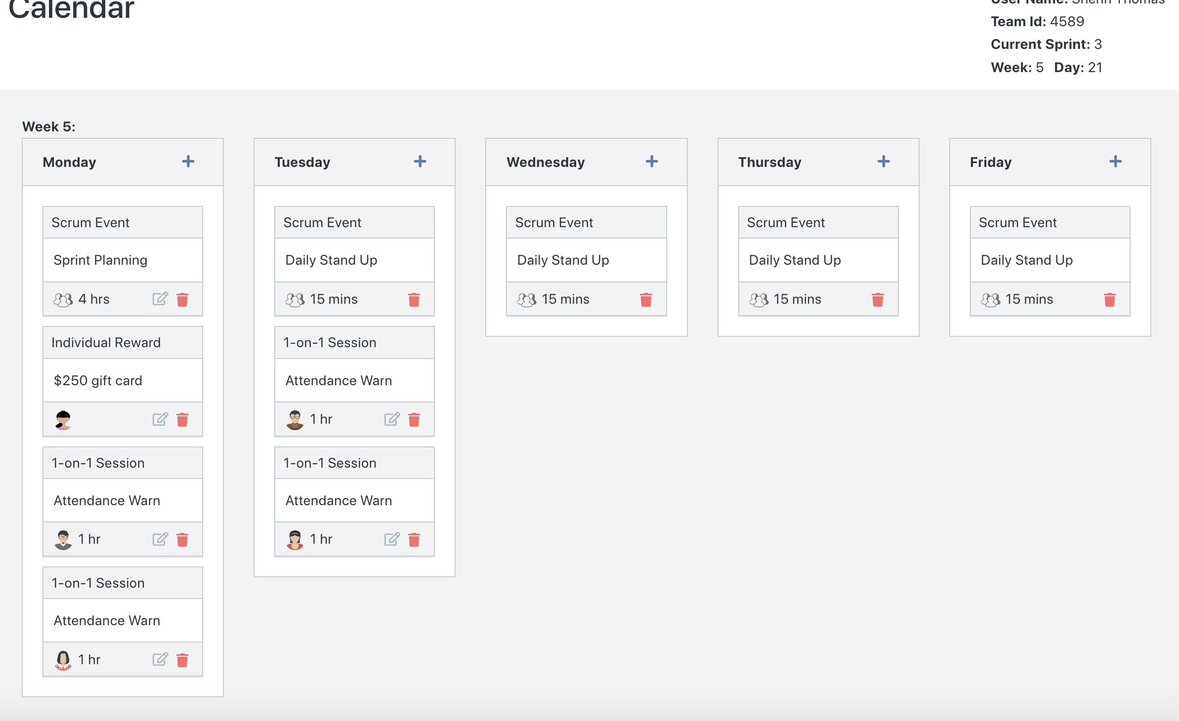

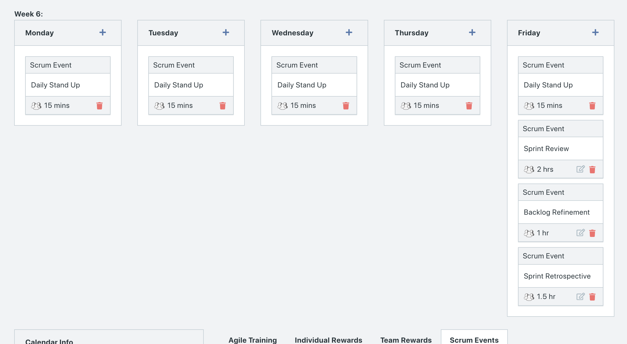

After running Week 5/ additions to Week 6:

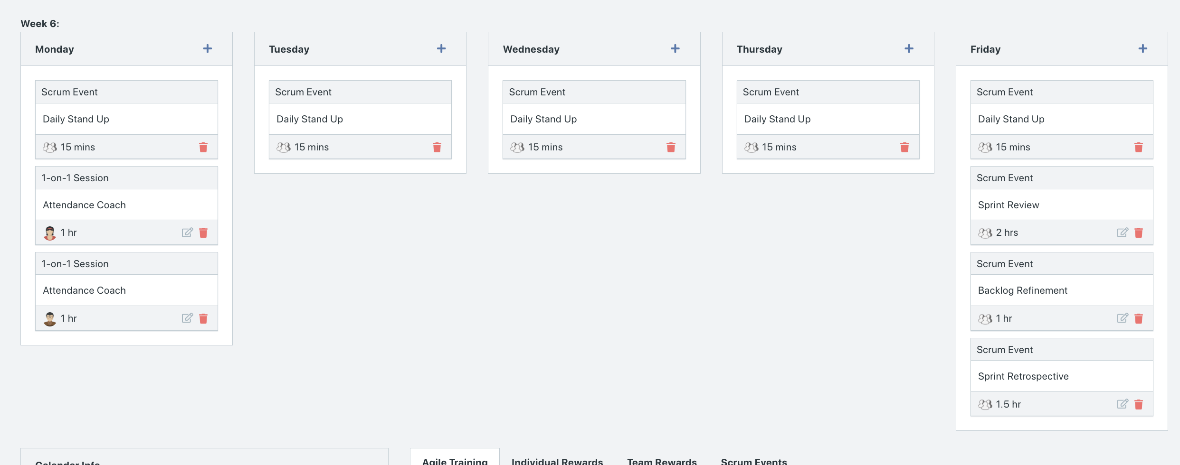

Explain the reason why you have scheduled the meetings listed shown on your calendar (if any)?

* The four people who missed more than three sprint activities, were given a one-one one meeting for a warning. We scheduled two people on Monday and two people on Tuesday. We did this to see if there would be a change in attendance with warnings compared to coaching meetings.
  + Nick, Maria, Yee Lee, Kamal
* Juma was awarded an individual reward ($250) because during the last sprint, we received a comment about Juma’s outstanding work.
* We added a Backlog Refinement on the last Friday on Sprint because since we only have one more sprint after Sprint 3, we want to ensure that all MVPs are delivered. Thus, we will refine the backlog if necessary to meet that condition.
* Additions to Week 6 after running Week 5
  + We noticed how the individuals scheduled for one-on-one warning meetings did not show up. Hence, we attempted to use one-on-one coaching meetings to see if that will make a difference increasing attendance. (We only tried it on two people to see the effects)

**BurnDown**

After competing sprint 3, paste a screen shot of the sprint 3 Burn Down Chart below.

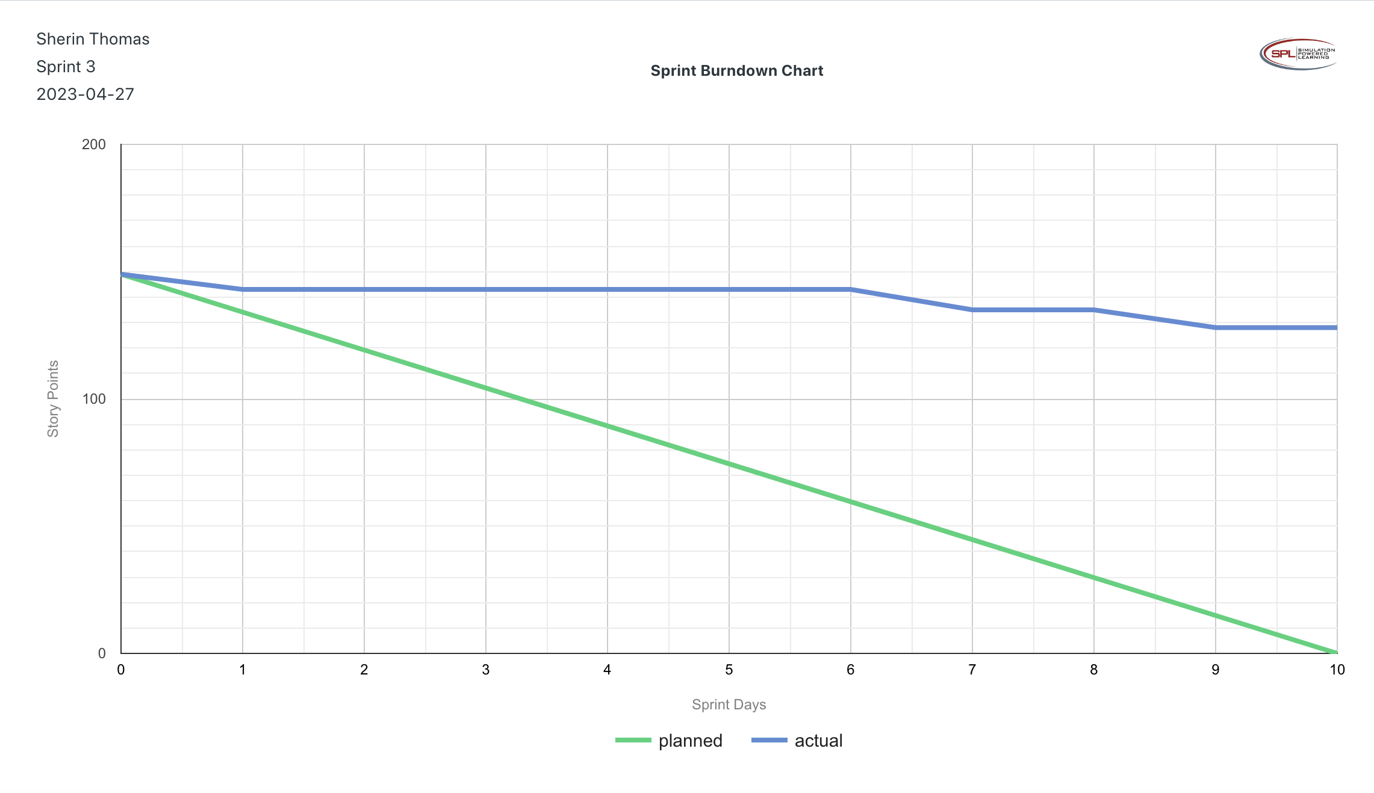

**Velocity Trend**

After competing sprint 3, paste the sprint 3 Velocity Chart below:

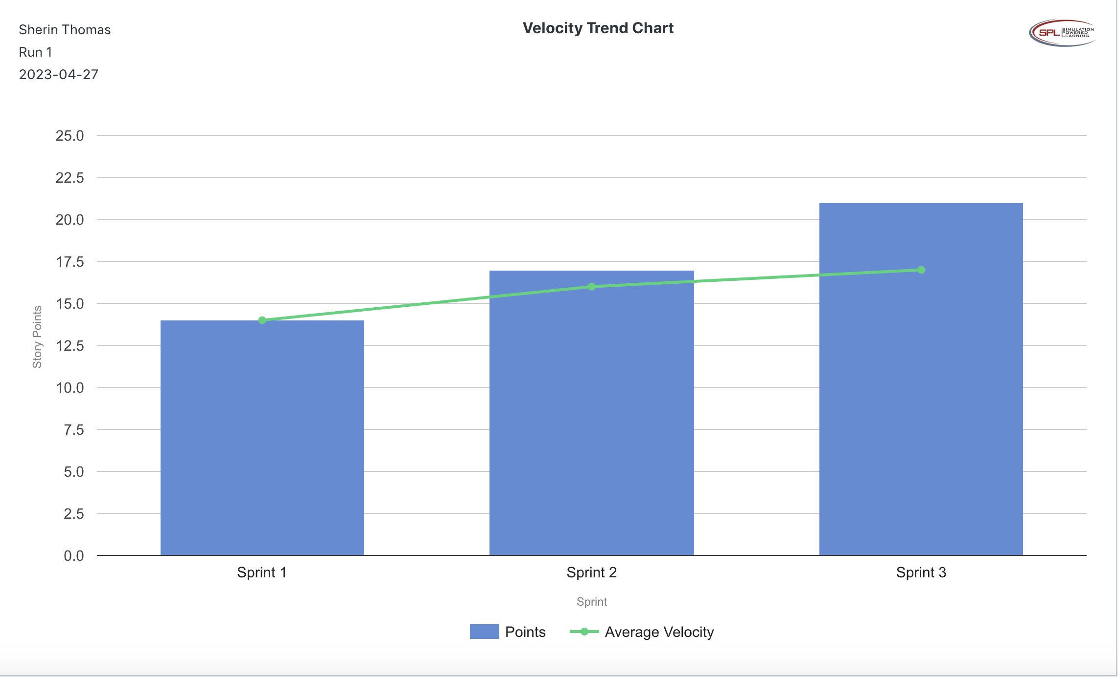

**Retrospective Meeting:**

How did you do in this sprint?

* We rate this sprint 4 out of 5 because we completed 15 user stories required for MVP with this Sprint 3, meaning we are only 3 MVP user stories away from delivering the MVP on time.

What problems, if any, did you encounter as you were executing the sprint?

* We experienced bugs with the developing BAAT application, meaning more requirements got added to the product backlog.
* There were secure documents reported to be thrown in the trash, and thus we have been asked to attend a security meeting.
* We still have the issue of people not attending scrum activities.

What changes, if any, are you are planning to make in the next sprint?

* Add a training session to improve productivity, considering the slow speed of completing user stories.
* Add more rewards to increase the morale of the developers since one-on-one meetings don’t seem to be making a difference.

**Answer following questions based on this Sprint:**

What is the velocity (in story points) for the sprint?

* 20 story points

What is the average velocity, minimum velocity, and maximum velocity (in story points) for the project across all sprints that have been completed so far?

* Average Velocity: 19 story points
* Minimum Velocity: 17 story points
* Maximum Velocity: 20 story points

Based on the current status of your project, do you believe that you will be able to complete the mandatory (or required) stories in the product backlog within the four sprints?  Explain your answer.

* We have completed 15 user stories required for MVP. We are left with 3 user stories for MVP, and thus, based on our velocity rate and the amount of remaining MVP user stories, we believe we will be able to deliver the MVP in 4 sprints.

4. Based on the current status of your project, do you believe that you will be able to complete all stories in the product backlog within the four sprints planned? Explain your answer.

* We do not believe we will be able to complete all the product backlog stories within the four sprints planned. Out of the 42 user stories required for the project, we have only completed the 15 MVP required stories, meaning we have 30 user stories left to do (which includes 3 MVP user stories), which is a very high velocity requirement for the only remaining sprint, which is Sprint 4.

**Sprint 4 - Week 7 and Week 8 (10 Points)**

**Product Backlog (one screen shot for sprint 4)**

Paste the screen shot of your Product Backlog below.

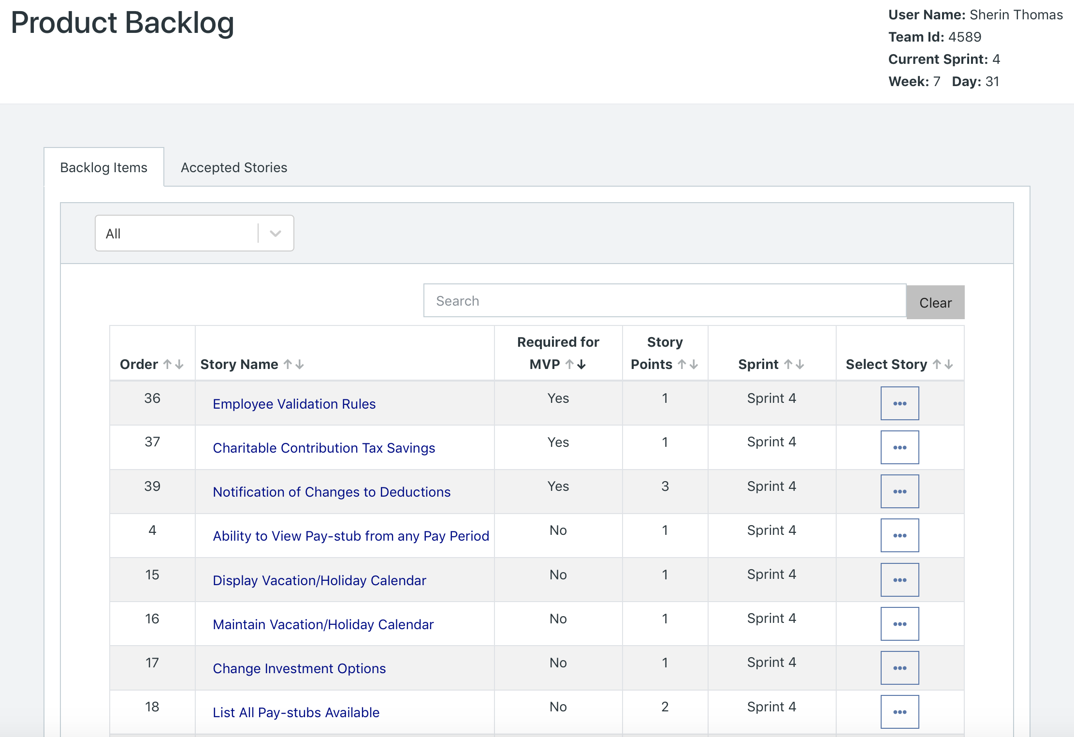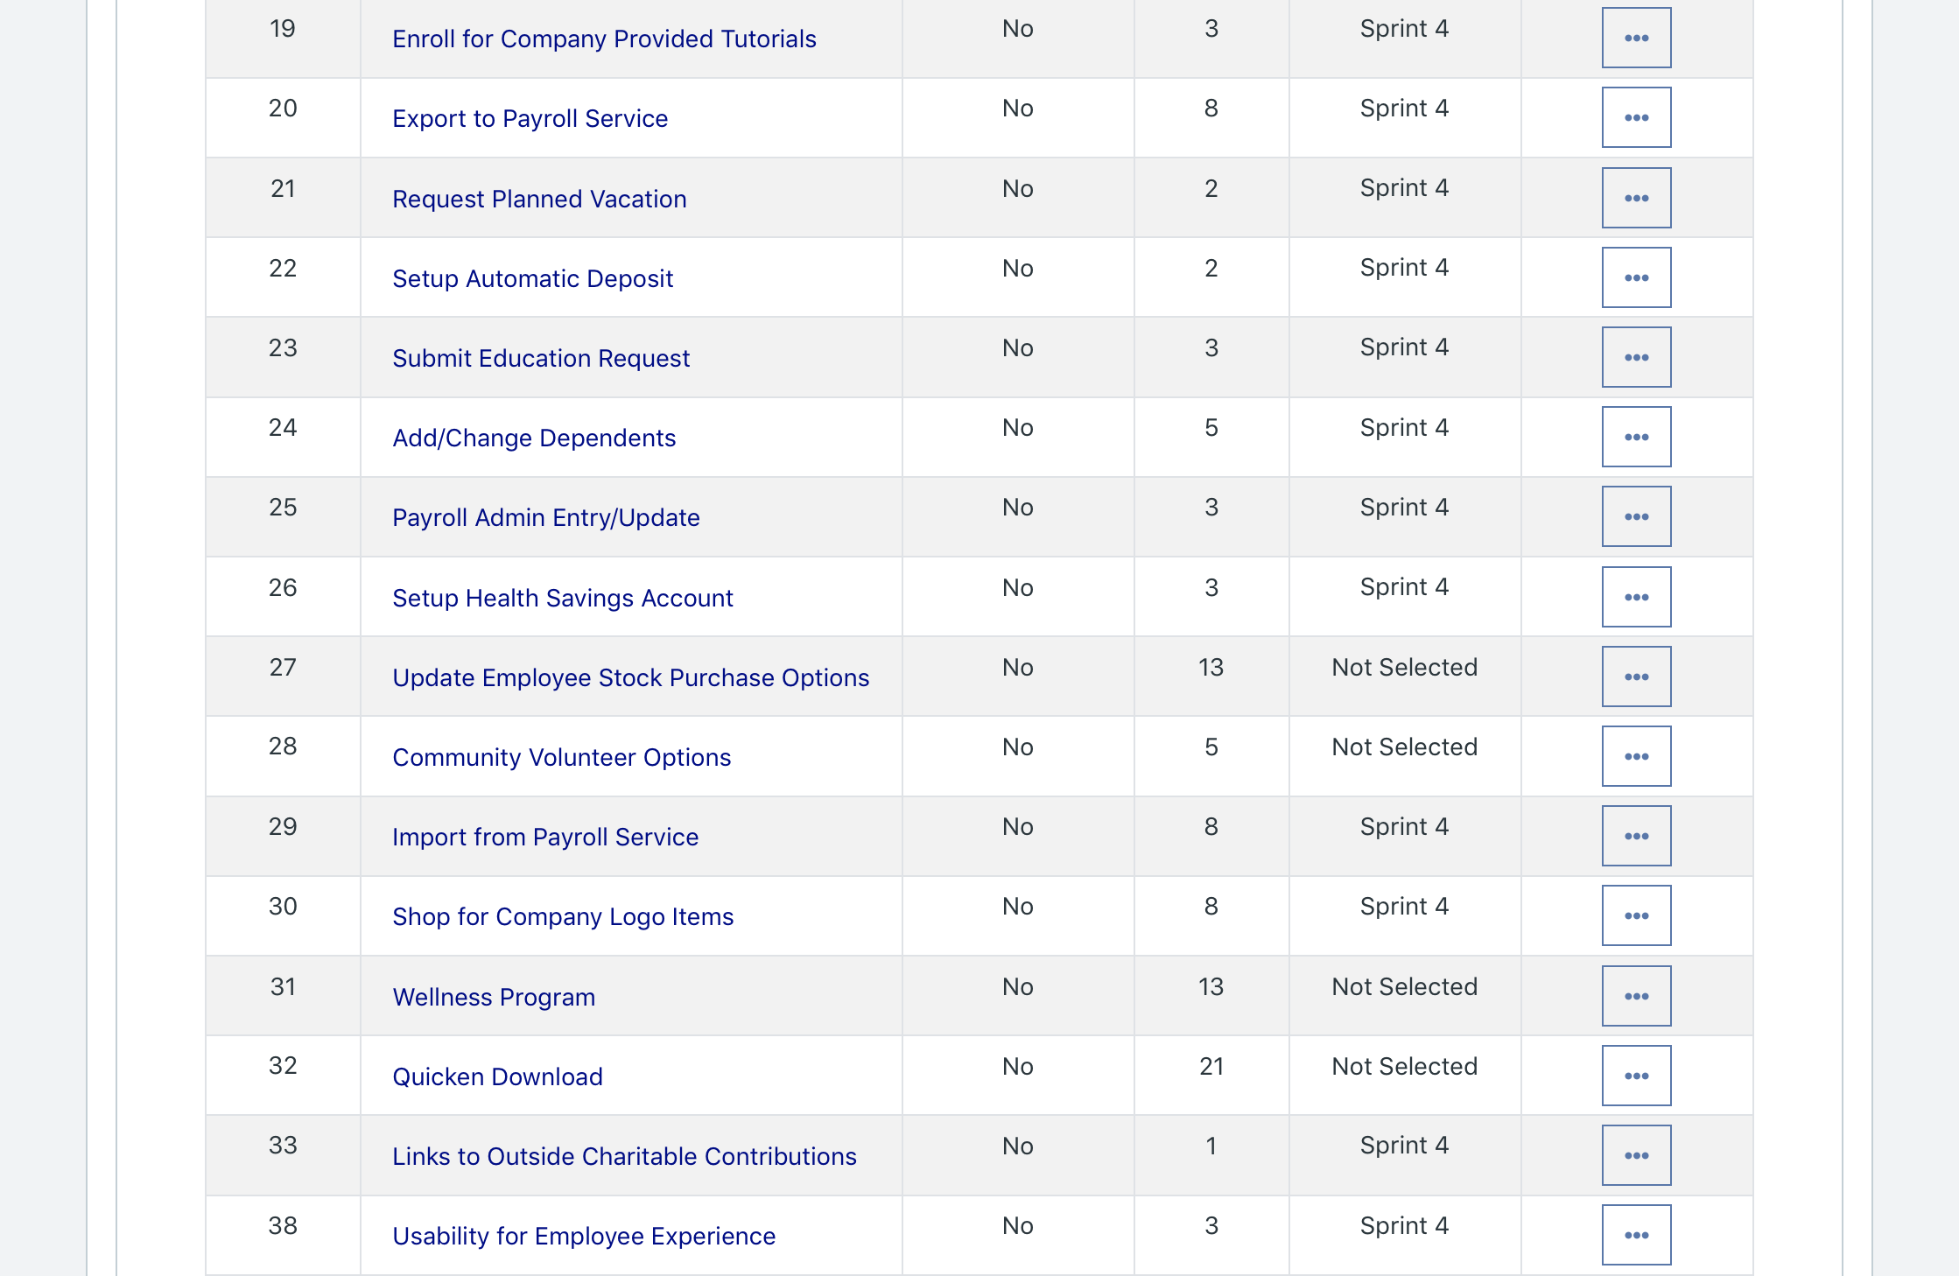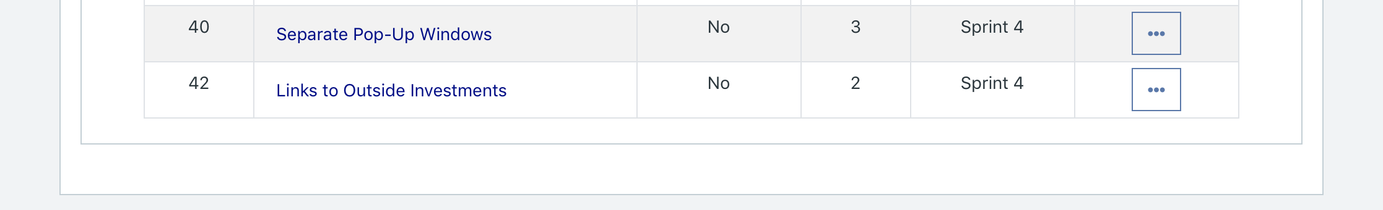

Please explain what you did in grooming the user stories in your Product Backlog and your reasoning for these decisions.

* We removed the user stories meant for Sprint 5 and 6 from Sprint 4 as per instructions,
* The three remaining MVP user stories (that were backlogged from earlier sprints), we assigned to Sprint 4 and gave them priority. This was done to ensure that any remaining MVP user stories would be worked on in Sprint 4, in hopes of delivering the MVP by the end of Sprint 4. We also put these user stories as high priortity in the Scrum Board.

**Scrum Board**

Scrum Board screen shot before sprint 4 has started

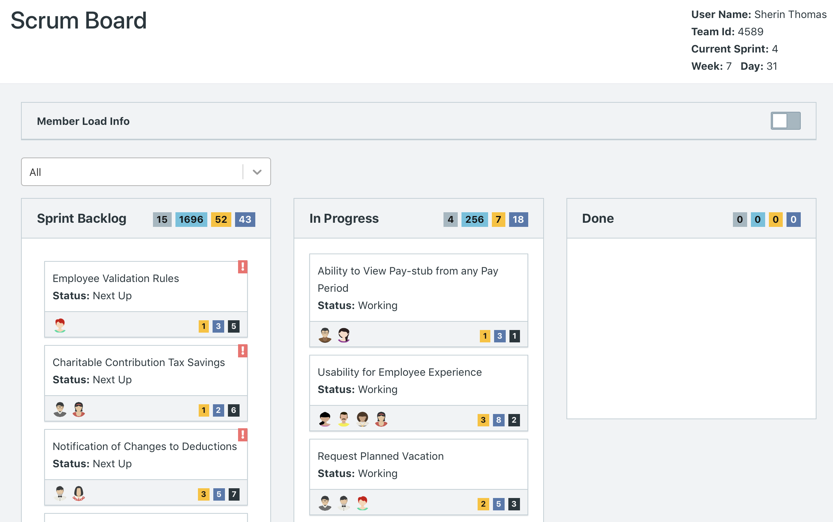

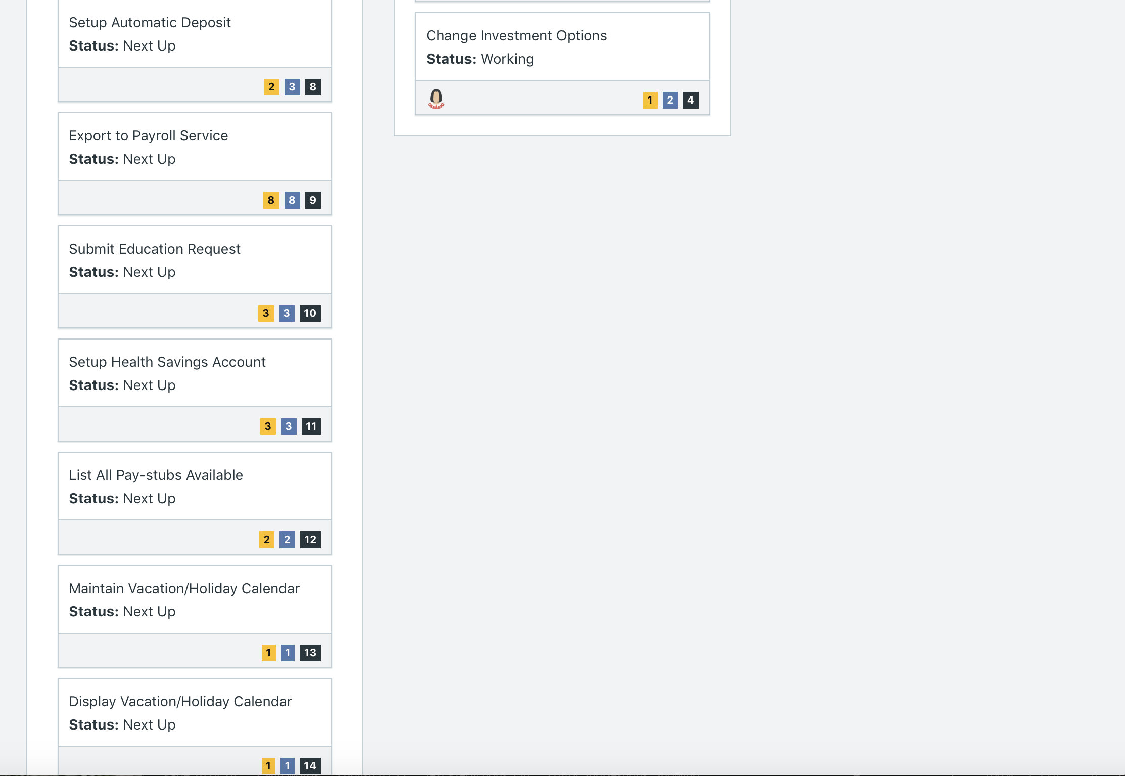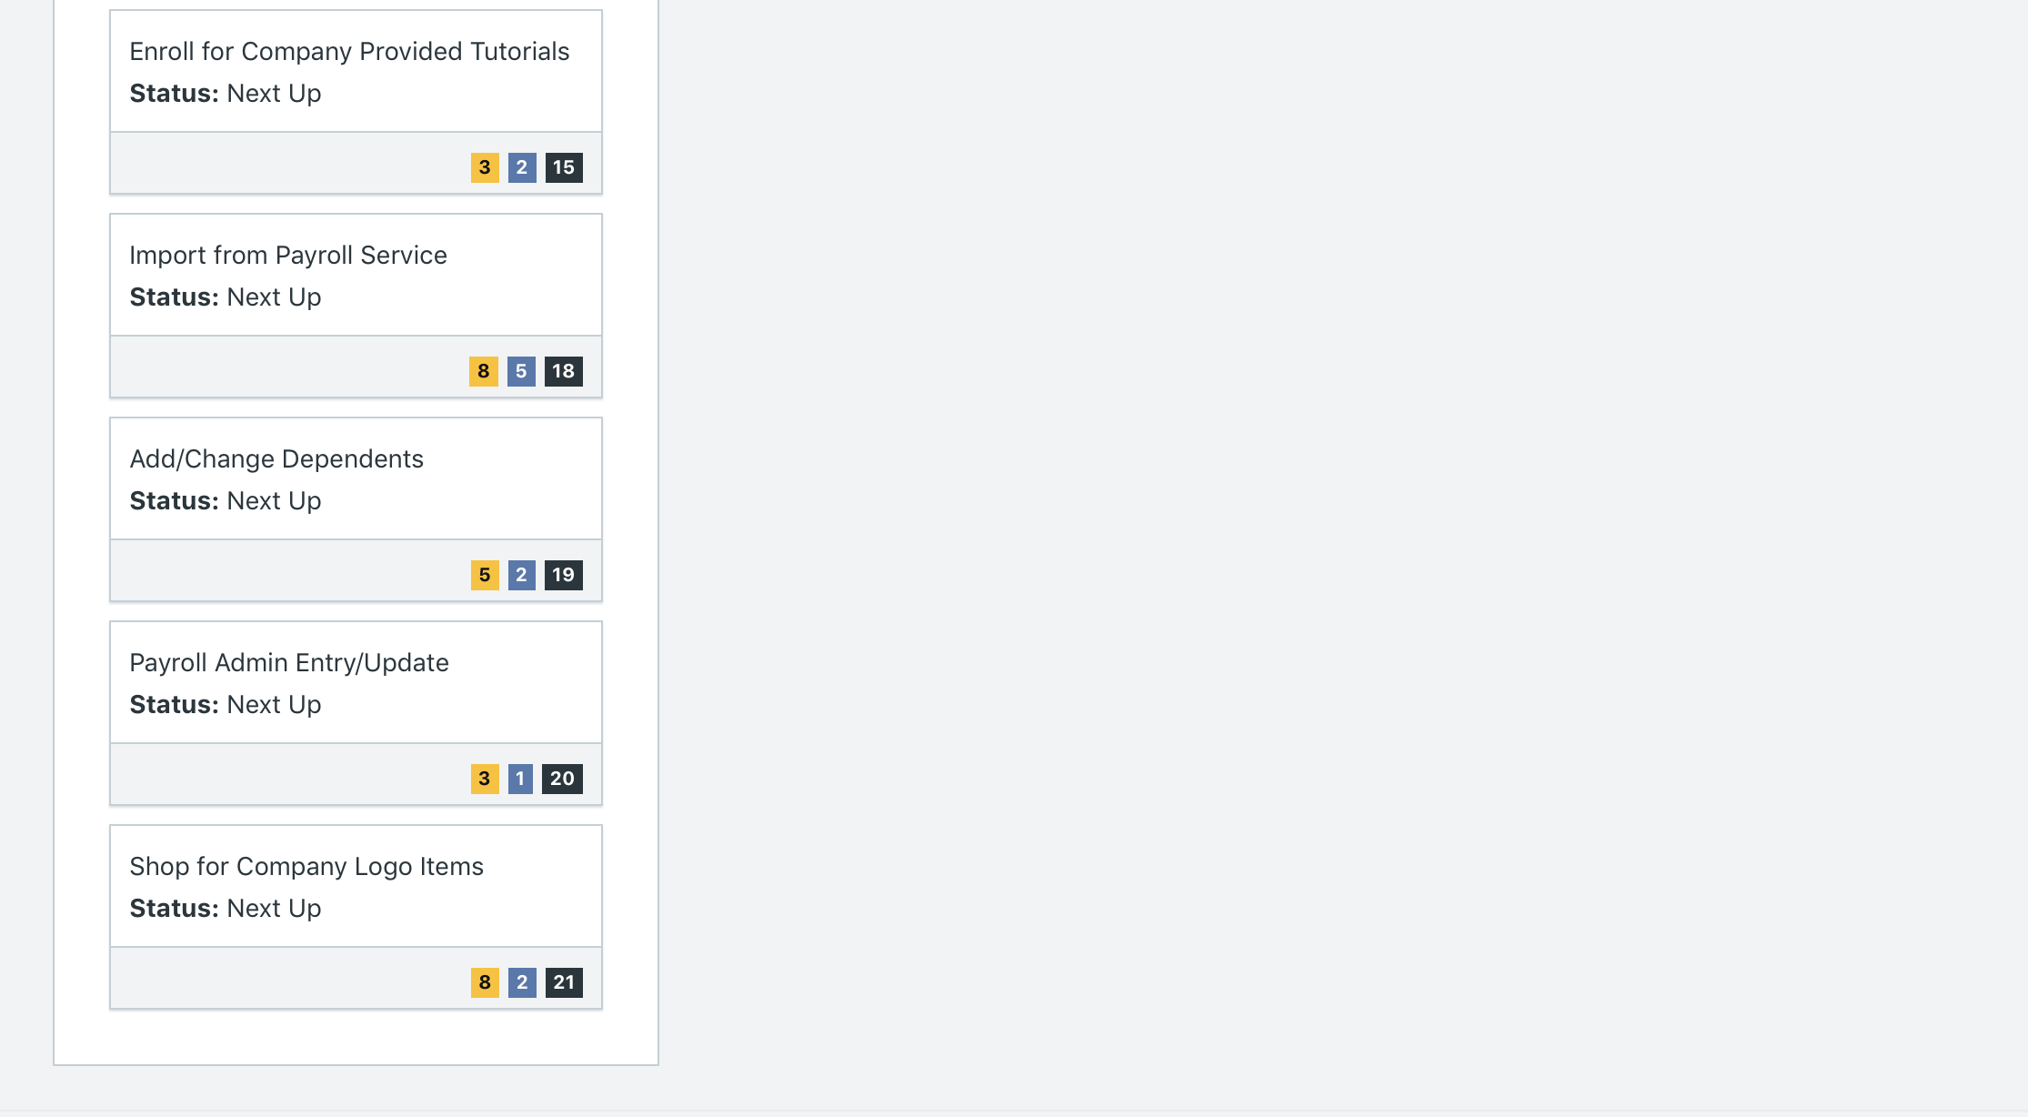

Scrum Board screen shot after 1st week of sprint 4

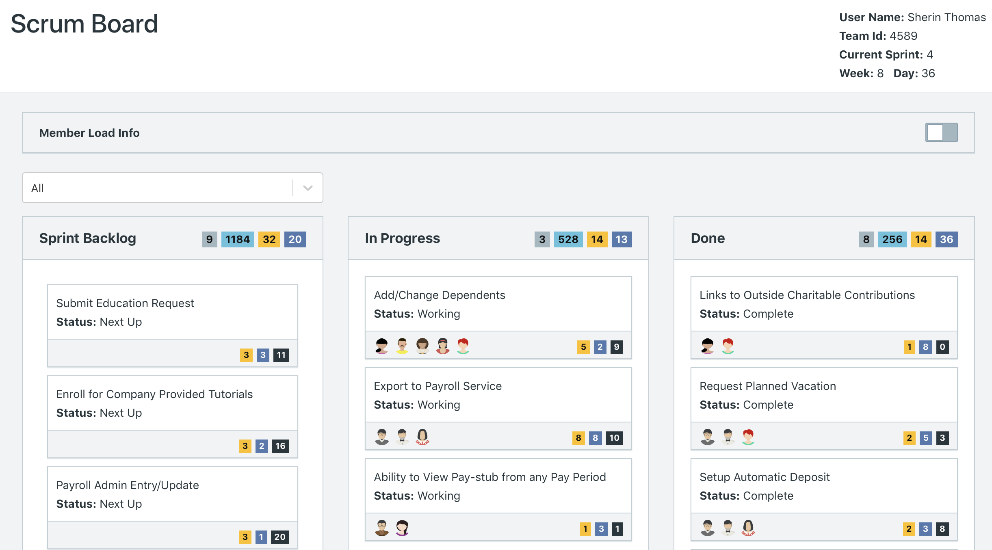

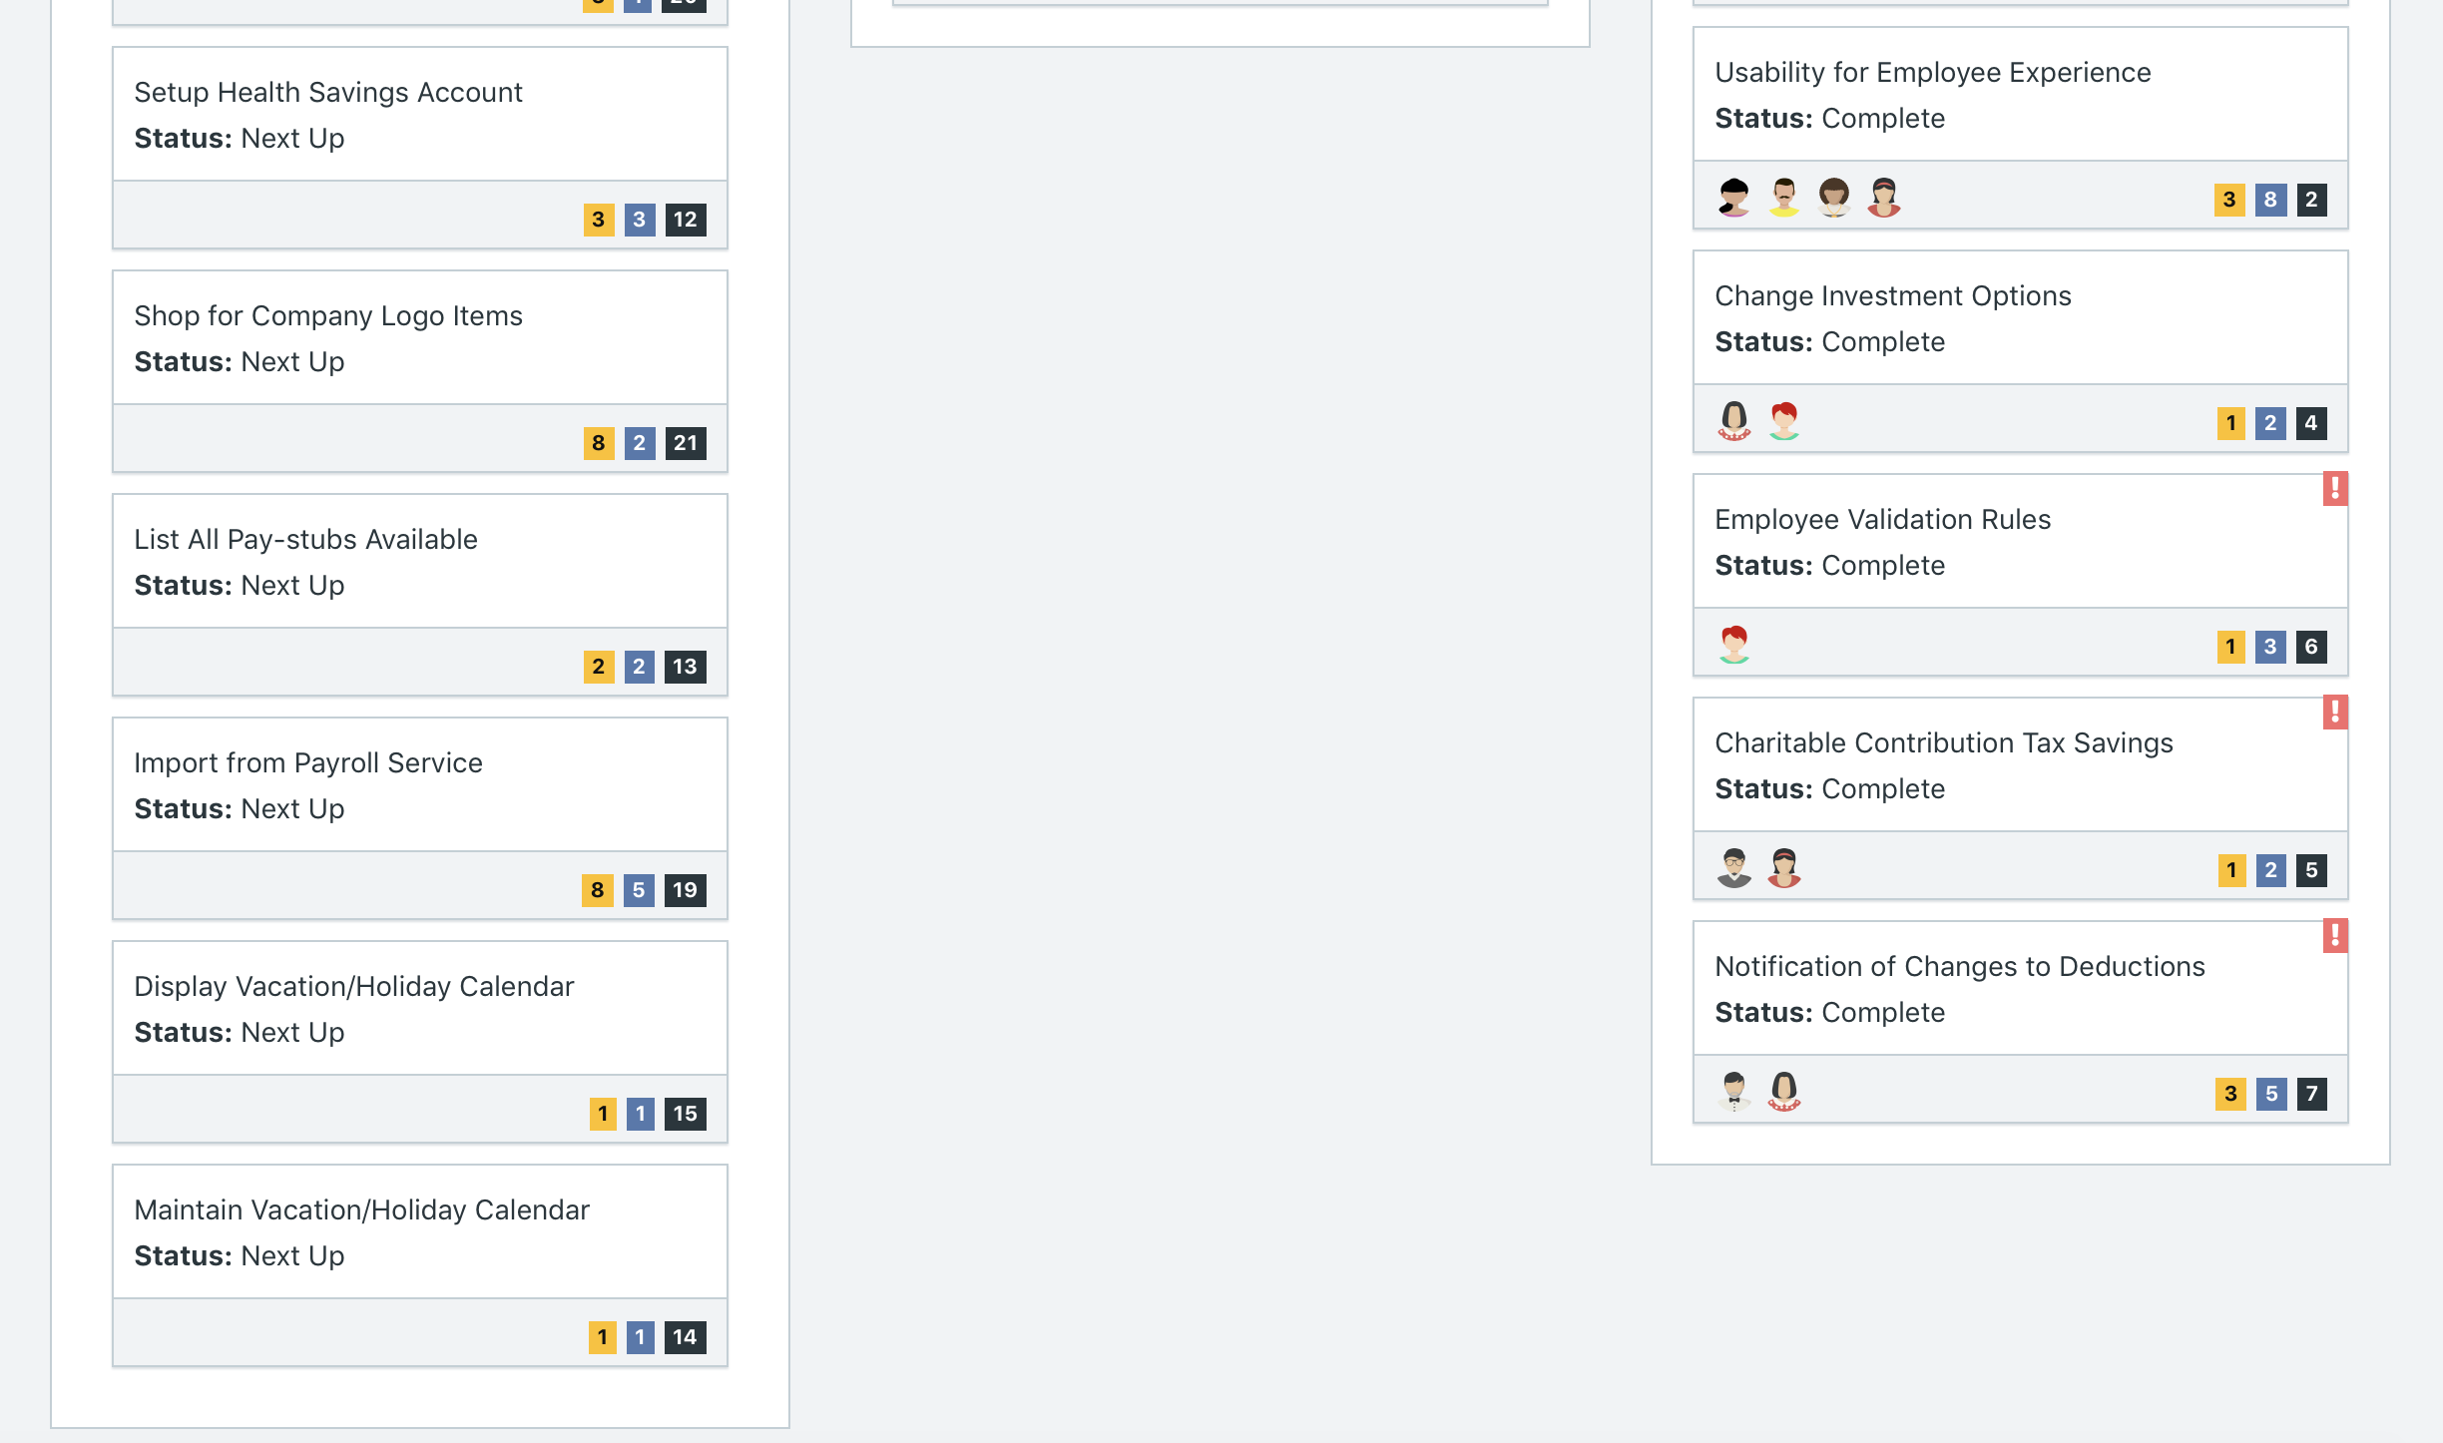

Scrum Board screen shot after 2nd week of Sprint 4

*After Sprint 4 was done, the software only allowed us to access the Reports and would not allow us to go back into Scrum Board. This may be due to the fact that the simulation was completed. Consequently, we have attached a screenshot of End of Run Report for Sprint 4, which like the Scrum Board, showcases which user stories were completed, are in progress, or are Next Up.*

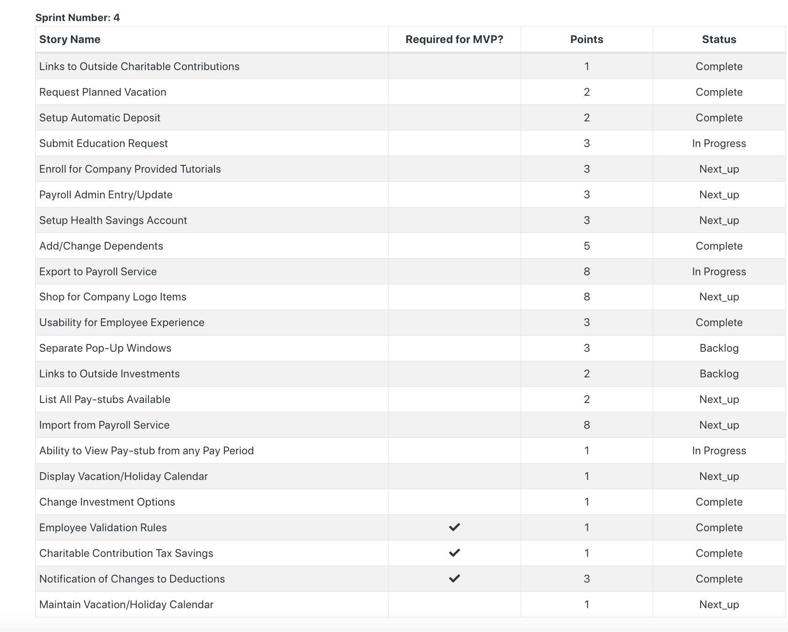

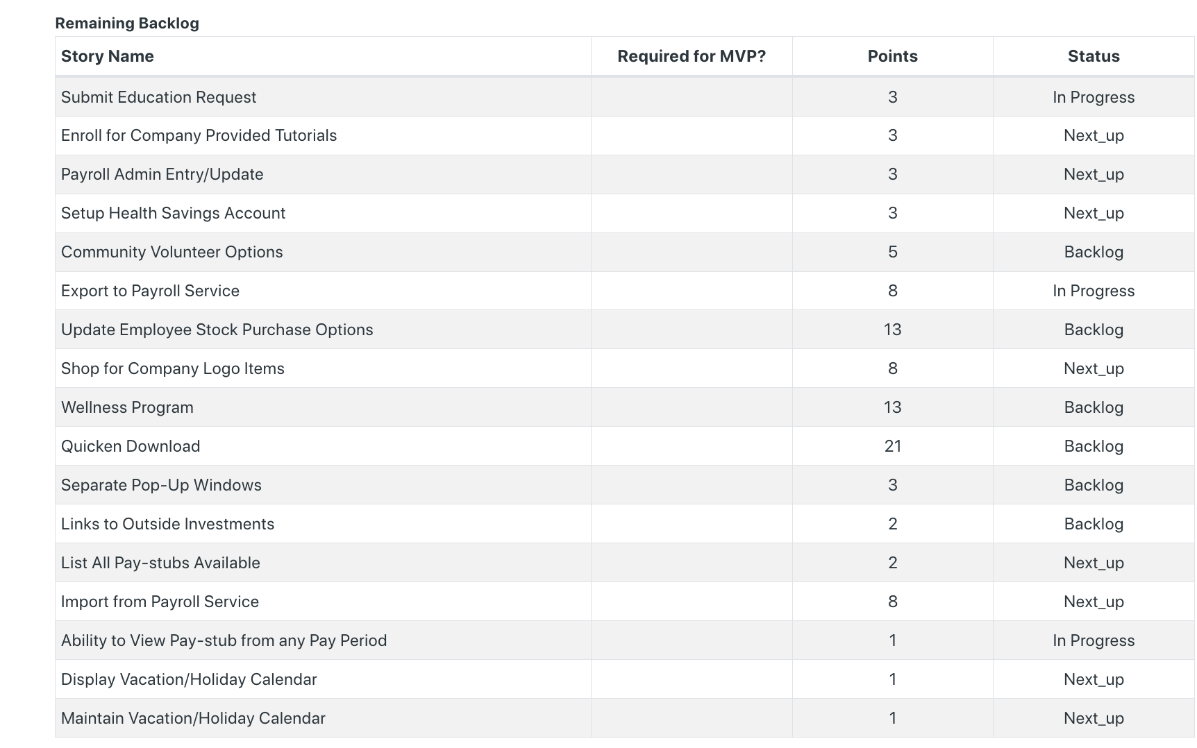

**Calendar**

Paste the screen shot of your Calendar for Sprint 4

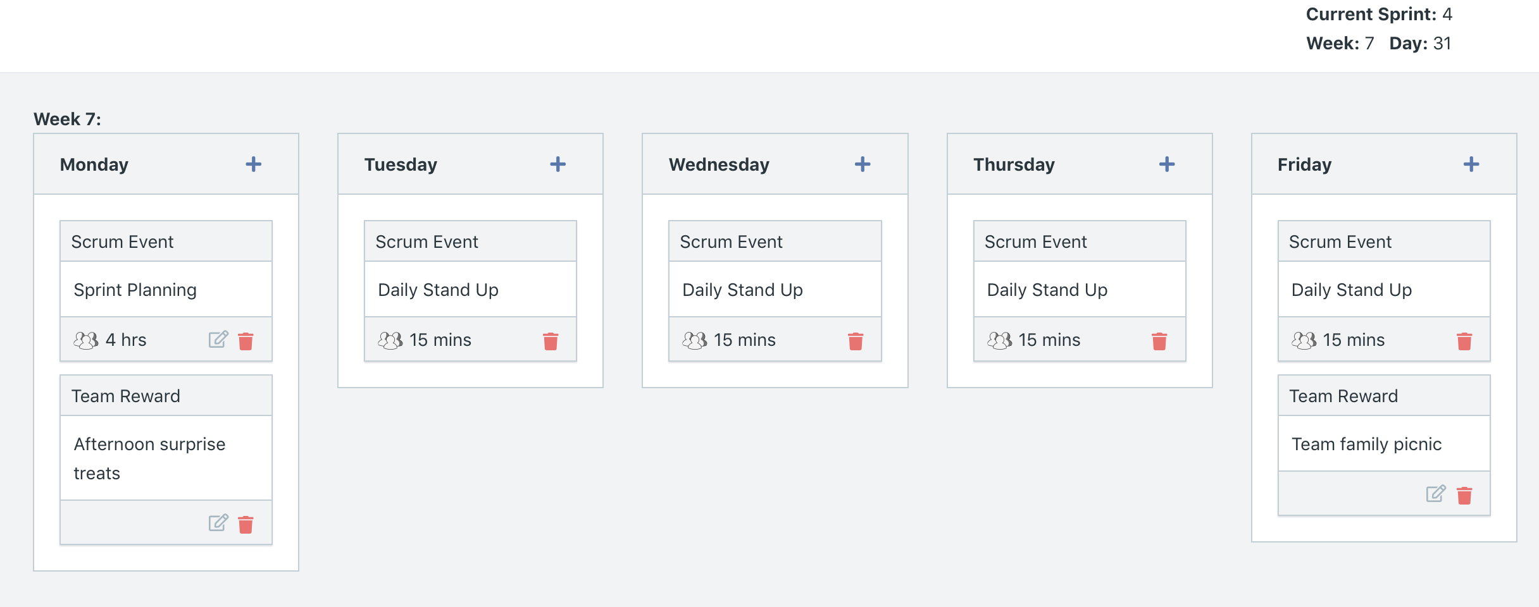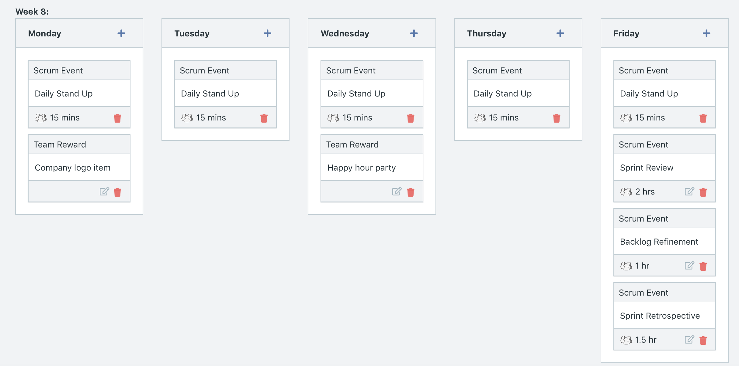

Explain the reason why you have scheduled the meetings listed shown on your calendar (if any)?

* Since the one-on-one meetings and the Agile Bootcamp have not been effective in increasing attendance for scum activities (Daily Standup) as well as increasing velocity, we decided to try another approach, which is to add more team rewards. We wanted to add team rewards to increase team morale and excitement for finishing the last 3 required MVP user stories
  + First Monday- afternoon surprise treats (to bring energy to the first day of the work week)
  + First Friday- family picnic (to celebrate the completion of the first week of Sprint 4)
  + Second Monday- company logo item (to bring energy to the first day of the work week)
  + Second Wednesday- happy hour (the last Friday of the Sprint has too many Sprint activities. Thus, we opted for Wednesday to provide energy and team bonding in the middle of the week,

**BurnDown**

After competing sprint 4, paste a screen shot of the sprint 4 Burn Down Chart below.

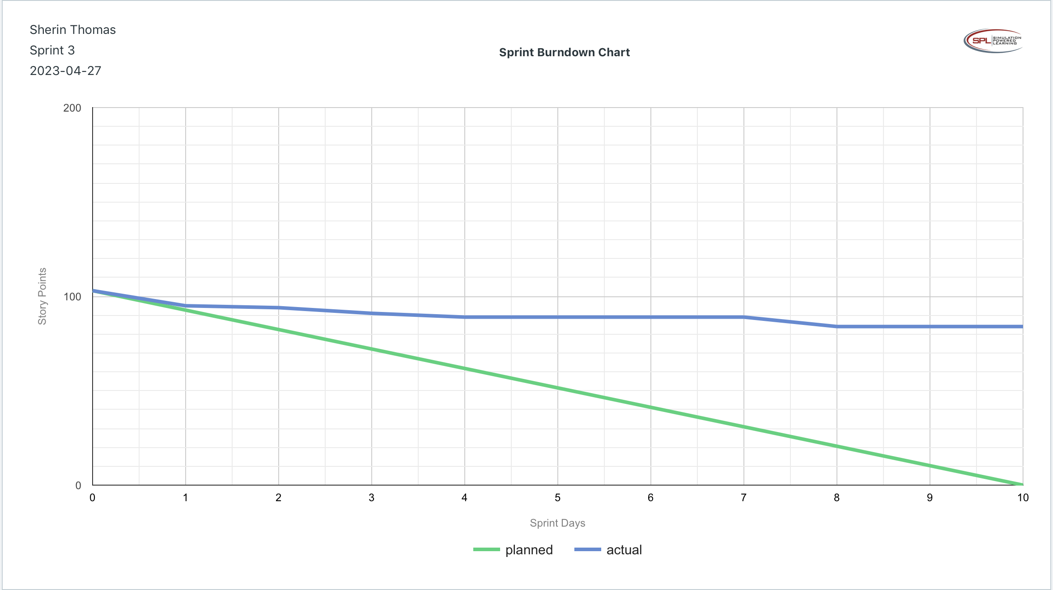

**Velocity Trend**

* After competing sprint 4, paste the sprint 4 Velocity Chart below:

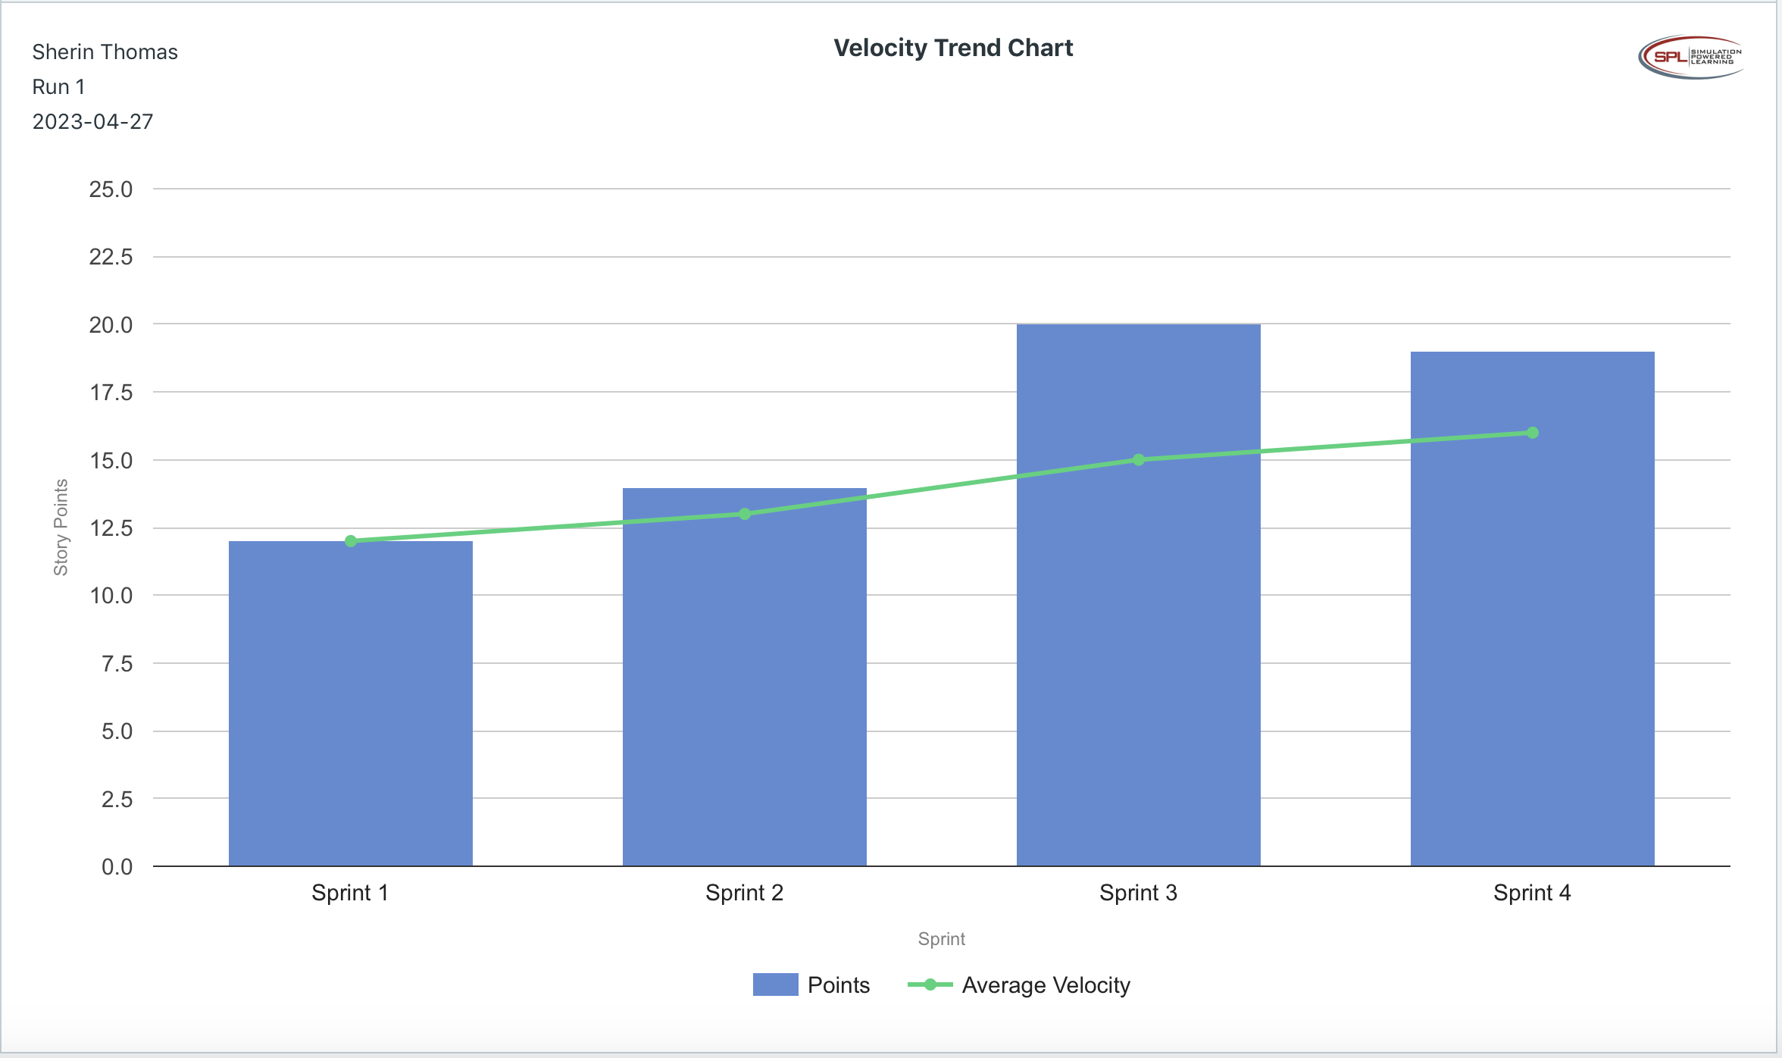

**Retrospective Meeting:**

How did you do in this sprint?

* We completed 9 user stories of the 22 user stories that were in this sprint. Hence, we only completed close to 40% (although we completed all MVP user stories). Due to being much behind schedule and a low completion rate, we rate this sprint 2/5.

What problems, if any, did you encounter as you were executing the sprint?

* We still continue to have absences from the sprint activities. In week 7, the absences decreased, and we thought it may be due to the increased team rewards added to the calendar. However, in week 8, the number of absences continued to increase.
* We are still not able to deliver the planned level of story points per sprint. We are only reaching about 40%-70% of completion of planned activities per sprint.

What changes, if any, are you are planning to make in the next sprint?

* Take strict action on absenteeism through warning meetings.
* Increase awareness of Agile best practices by adding at least two training workshops within the four sprints.
* Increase team morale by starting off with rewards in the first week of a Sprint.
* Rearrange the backlog to give highest priority to the non-MVP user stories that that have the largest number of story points to complete (may take the longest amount of time) and provide large business values.

**Answer following questions based on this Sprint:**

What is the velocity (in story points) for the sprint?

* 19 story points

What is the average velocity, minimum velocity, and maximum velocity (in story points) for the project across all sprints that have been completed so far?

* Average velocity: 19 story points
* Minimum velocity: 17 story points
* Maximum velocity: 20 story points

Did you deliver all required functionality needed for the MVP?  Explain your answer.

* Yes, all MVPs were delivered within 4 sprints. Based on our scrum board as well as our End of Run report at the end of Sprint 4, there are 18 total MVP user stories, and all 18 MVP user stories were completed.

Did you deliver all the user stories in the product backlog? What were the three most significant items that effected your team’s performance?

* No, we could not deliver all the user stories in the product backlog.
* Factors affecting team performance were- absenteeism, low Morale, lack of Agile knowledge and trust in the process.